Task-1: Create MariaDB Database on EC2
Objective
To launch an Amazon EC2 instance and install MariaDB Database Server using EC2 User Data. The objective is to automate the database installation process and create a database that can be used by applications.

Architecture
Amazon EC2 Instance
↓
User Data Script
↓
MariaDB Installation
↓
Database Creation
↓
Database Ready for Use

Prerequisites
- AWS Account
- EC2 Access
- Key Pair
- Security Group
- Internet Connectivity

Implementation Steps
Step 1: Launch EC2 Instance
- Logged into AWS Management Console.
- Navigated to EC2 Dashboard.
- Clicked Launch Instance.
- Entered instance name:
MariaDB-Server
- Selected AMI:
Amazon Linux 2023
- Selected instance type:
t2.micro
- Selected existing Key Pair.

Step 2: Configure Security Group
Configured inbound rules:
Type | Port | Source
SSH | 22 | My IP
MariaDB | 3306 | My IP
This allows administrators to connect to the server and access MariaDB.

Step 3: Add User Data Script
In Advanced Details section, added the following User Data script:
#!/bin/bash

dnf update -y

dnf install mariadb105-server -y

systemctl start mariadb

systemctl enable mariadb
Purpose:
- Updates operating system packages.
- Installs MariaDB Server.
- Starts MariaDB service.
- Enables MariaDB service to start automatically after reboot.

Step 4: Launch EC2 Instance
Clicked Launch Instance and waited until:
Instance State = Running
Status Checks = 2/2 Passed

Step 5: Connect to EC2 Instance
Connected to the instance using SSH.
ssh -i key.pem ec2-user@Public-IP
Successfully logged into the EC2 server.

Step 6: Verify MariaDB Installation
Checked MariaDB version:
mariadb --version
Output confirmed successful installation of MariaDB Server.

Step 7: Verify MariaDB Service
Checked service status:
sudo systemctl status mariadb
Verified:
active (running)

Step 8: Secure MariaDB Installation
Executed:
sudo mysql_secure_installation
Configured:
- Root password
- Removed anonymous users
- Disabled remote root login
- Removed test database
- Reloaded privilege tables
This improves database security.

Step 9: Login to MariaDB
Connected as root user:
sudo mysql -u root -p
Successfully entered MariaDB console.

Step 10: Create Database
Created a database:
CREATE DATABASE companydb;
Output:
Query OK, 1 row affected

Step 11: Verify Database Creation
Executed:
SHOW DATABASES;
Output displayed:
companydb
information_schema
mysql
performance_schema
This confirmed successful database creation.

Validation
AWS Console Verification
EC2 Verification
Verified:
EC2 Instance State = Running
Status Checks = Passed
Security Group Verification
Verified inbound rules:
22 - SSH
3306 - MariaDB
EBS Verification
Verified root EBS volume attached to EC2 instance.
EC2
→ Elastic Block Store
→ Volumes
User Data Verification
Verified User Data execution through:
EC2
→ Instance
→ Actions
→ Monitor and Troubleshoot
→ Get System Log
Confirmed MariaDB installation commands executed successfully.

Result
Successfully launched an EC2 instance and installed MariaDB Database Server using EC2 User Data automation. Verified service status, secured the database installation, created a database named companydb, and confirmed successful operation through AWS Console and MariaDB commands.
Task Status: Completed Successfully. ✅
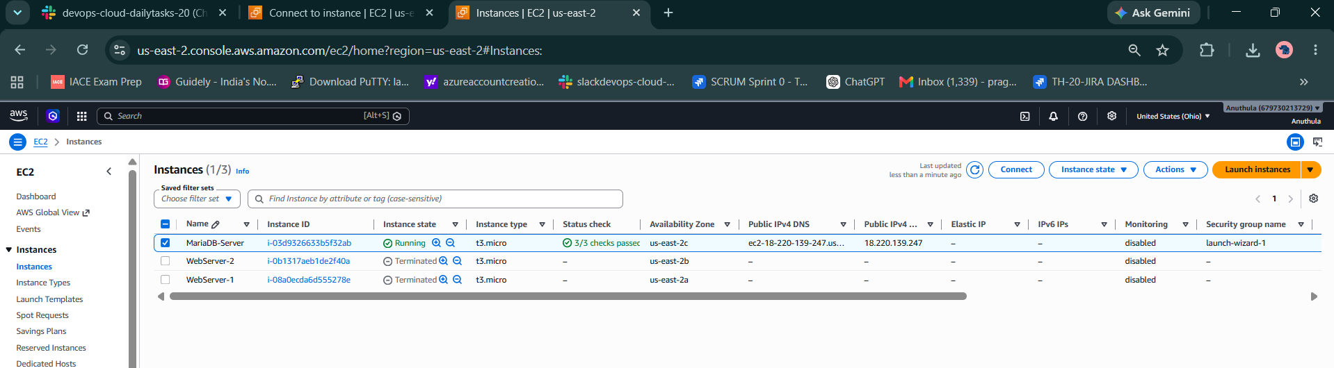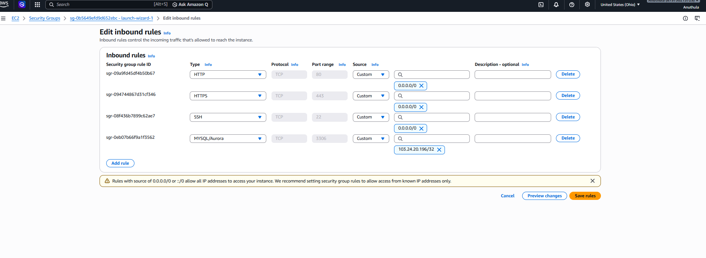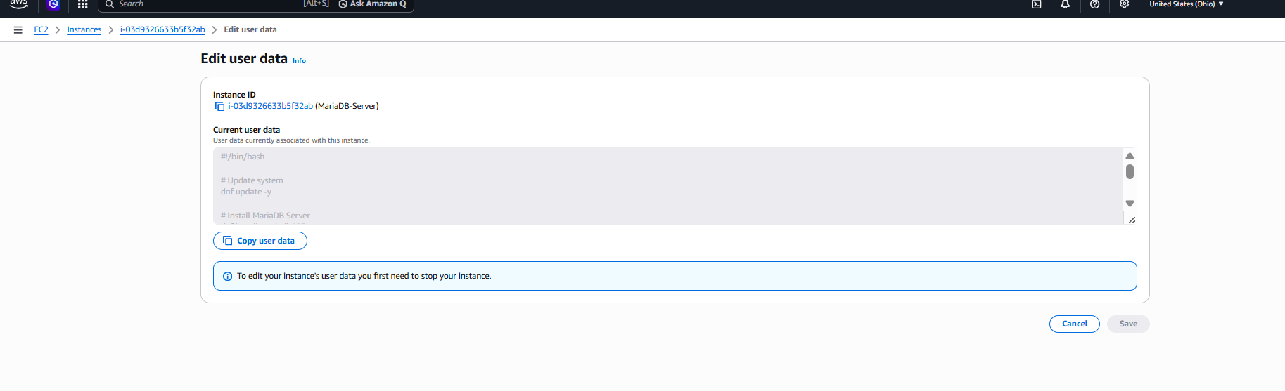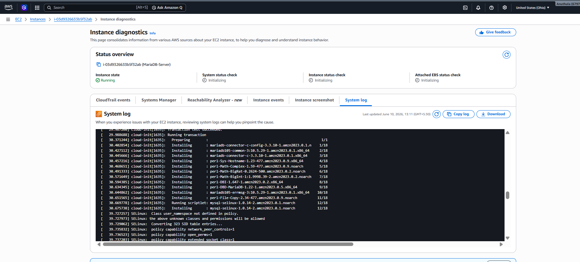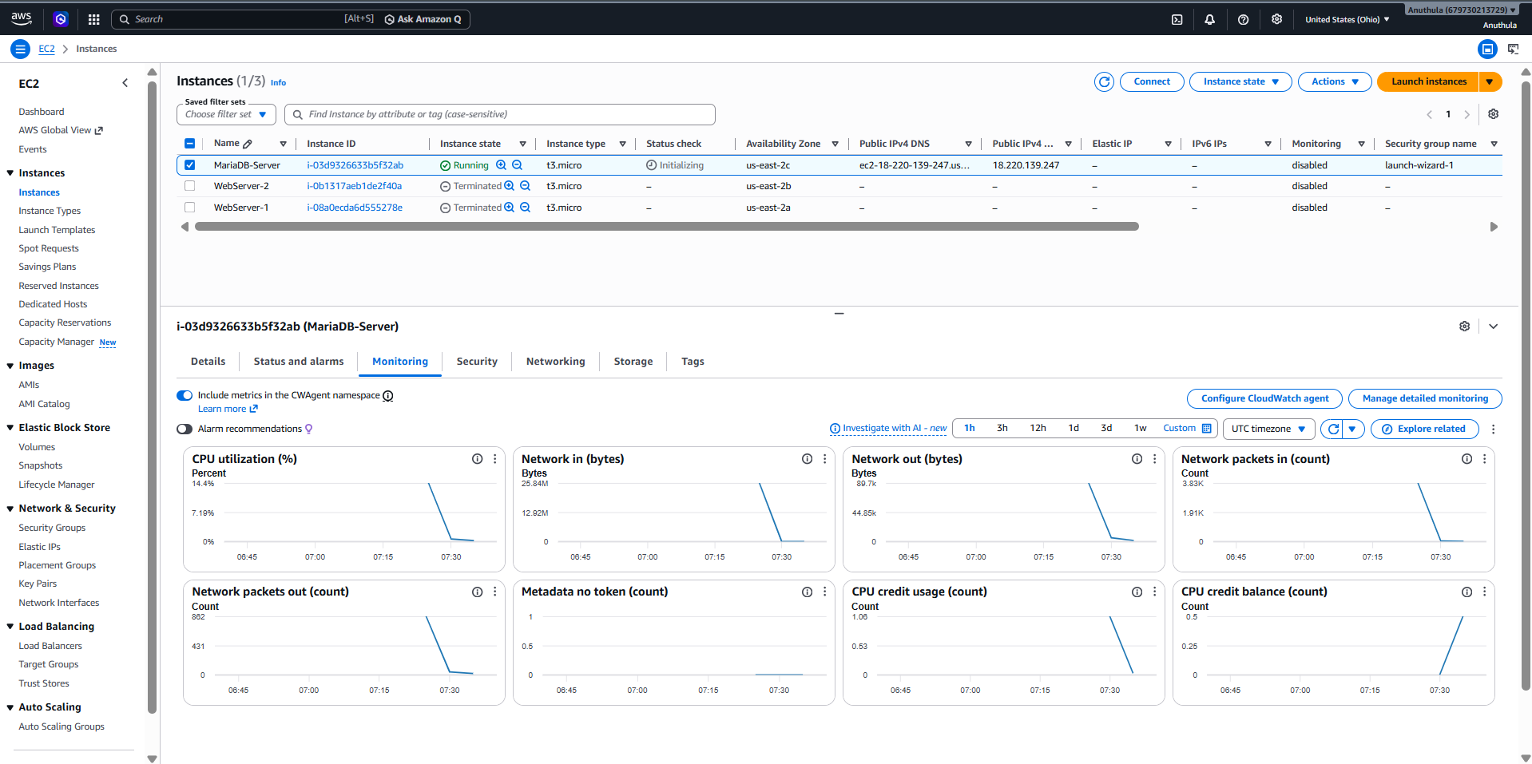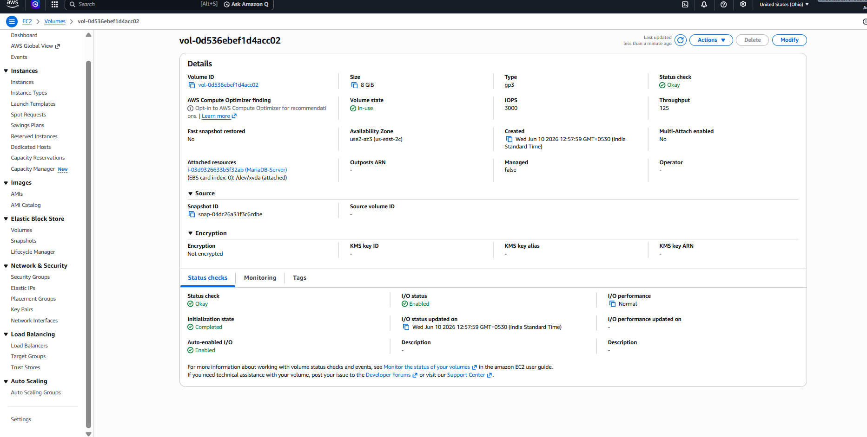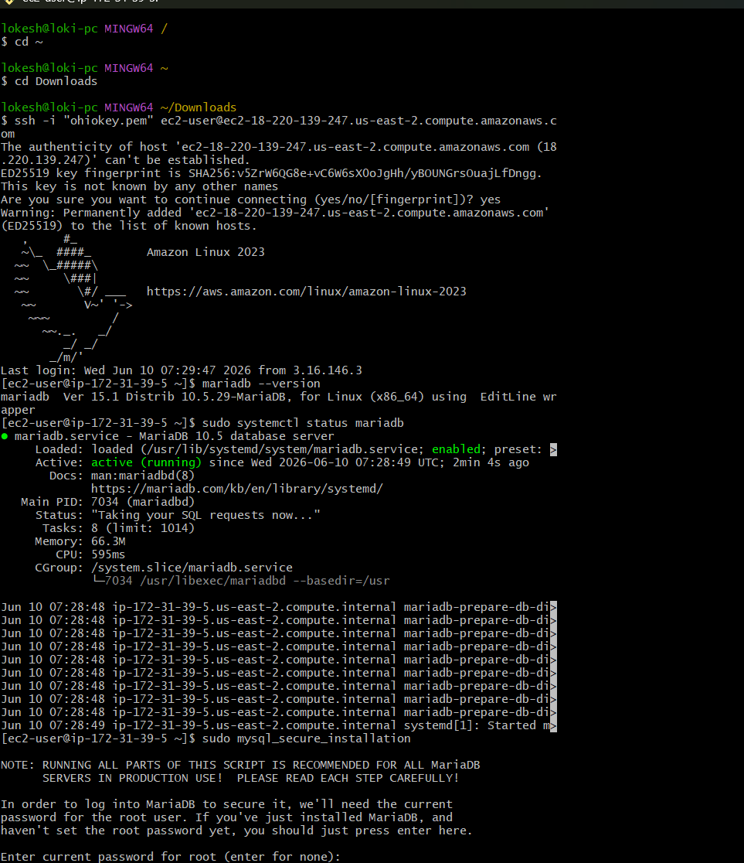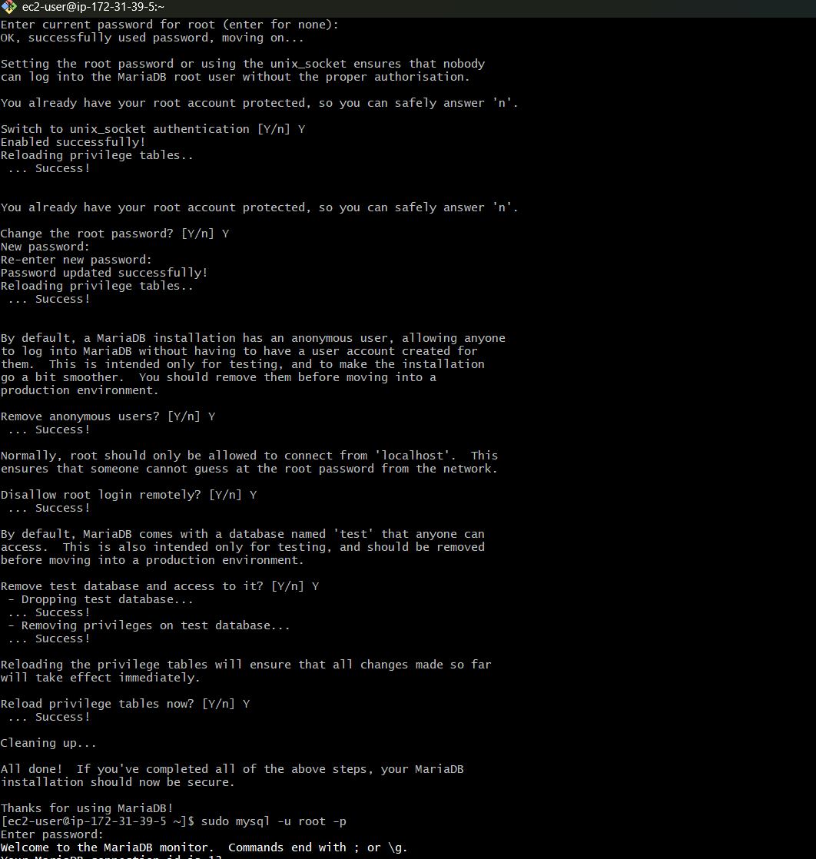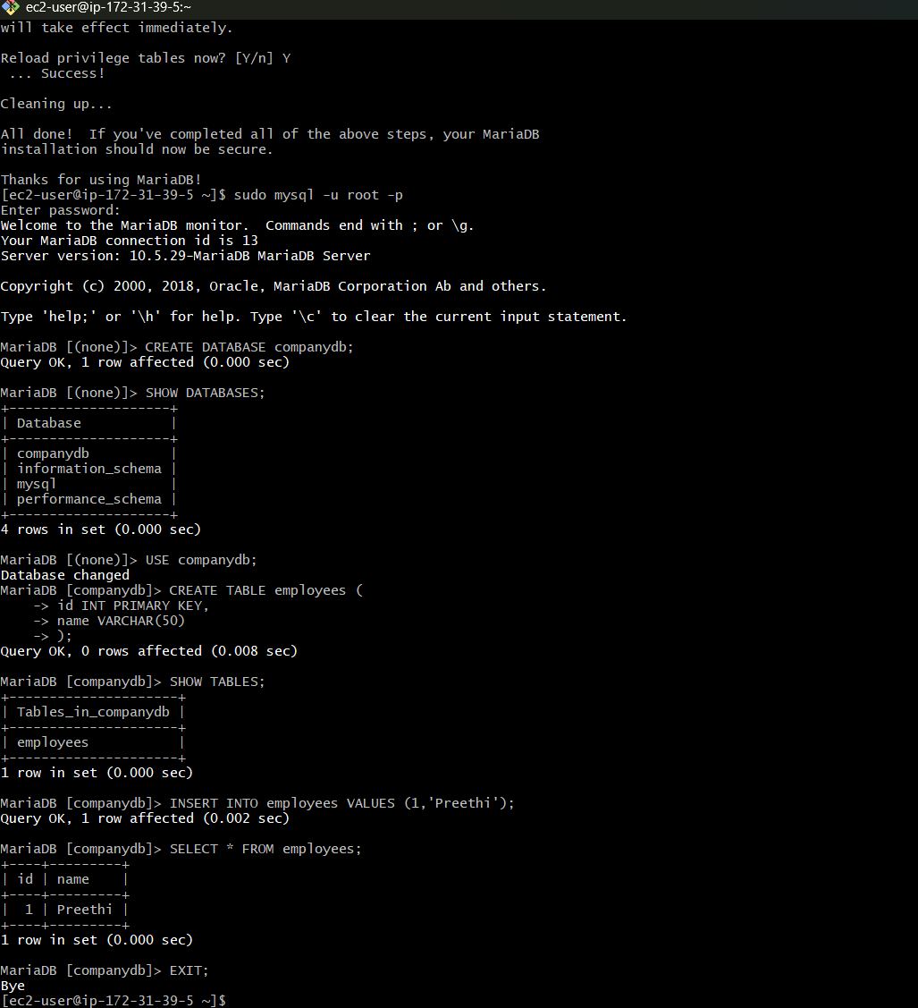

Task-2: Insert Dummy Data into MariaDB Database
Objective
The objective of this task is to insert sample records into a MariaDB database hosted on an Amazon EC2 instance. This helps verify that the database is functioning correctly and can store and retrieve data successfully.

Architecture
Amazon EC2 Instance
↓
MariaDB Database
↓
companydb
↓
employees Table
↓
Dummy Employee Records

Prerequisites
- Amazon EC2 instance is running.
- MariaDB Server is installed and configured.
- Database companydb is already created.
- Root access to MariaDB is available.

Implementation Steps
Step 1: Connect to EC2 Instance
Connected to the EC2 instance using SSH.
ssh -i "ohiokey.pem" ec2-user@<public-ip>
Successfully logged into the Linux server.

Step 2: Login to MariaDB
Connected to MariaDB as root user.
sudo mysql -u root -p
Entered the root password and accessed the MariaDB console.

Step 3: Verify Database
Listed all available databases.
SHOW DATABASES;
Verified that the database companydb exists.

Step 4: Select Database
Switched to the required database.
USE companydb;
Output:
Database changed

Step 5: Verify Existing Table Structure
Checked the structure of the employees table.
DESC employees;
It was observed that the table contained only the following columns:
id
name
Since the task required storing employee details such as department and salary, the table structure was modified.

Step 6: Remove Existing Table
Deleted the existing employees table.
DROP TABLE employees;
This was done to recreate the table with the required columns.

Step 7: Create Employees Table
Created a new table with additional fields.
CREATE TABLE employees (
id INT PRIMARY KEY,
name VARCHAR(50),
department VARCHAR(50),
salary INT
);
The table was successfully created.

Step 8: Insert Dummy Data
Inserted sample employee records into the table.
INSERT INTO employees VALUES
(1,'Preethi','DevOps',60000),
(2,'Rahul','Database',55000),
(3,'Anjali','Cloud',65000),
(4,'Kiran','Networking',50000),
(5,'Sneha','Security',70000);
Output:
Query OK, 5 rows affected

Step 9: Verify Inserted Data
Executed the following query:
SELECT * FROM employees;
Verified that all records were successfully inserted into the database.
Expected Output:
+----+---------+------------+--------+
| id | name | department | salary |
+----+---------+------------+--------+
| 1 | Preethi | DevOps | 60000 |
| 2 | Rahul | Database | 55000 |
| 3 | Anjali | Cloud | 65000 |
| 4 | Kiran | Networking | 50000 |
| 5 | Sneha | Security | 70000 |
+----+---------+------------+--------+

Validation
Database Validation
Verified that the database exists.
SHOW DATABASES;
Table Validation
Verified that the employees table exists.
SHOW TABLES;
Data Validation
Verified that all inserted records are present.
SELECT * FROM employees;

Result
Successfully connected to the MariaDB database hosted on an Amazon EC2 instance, created an employee table with required fields, inserted dummy employee records, and verified the data using SQL queries.
Task Status: Completed Successfully ✅
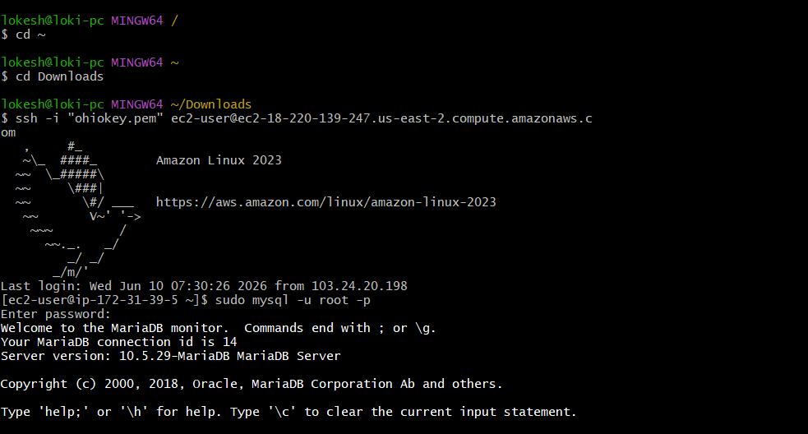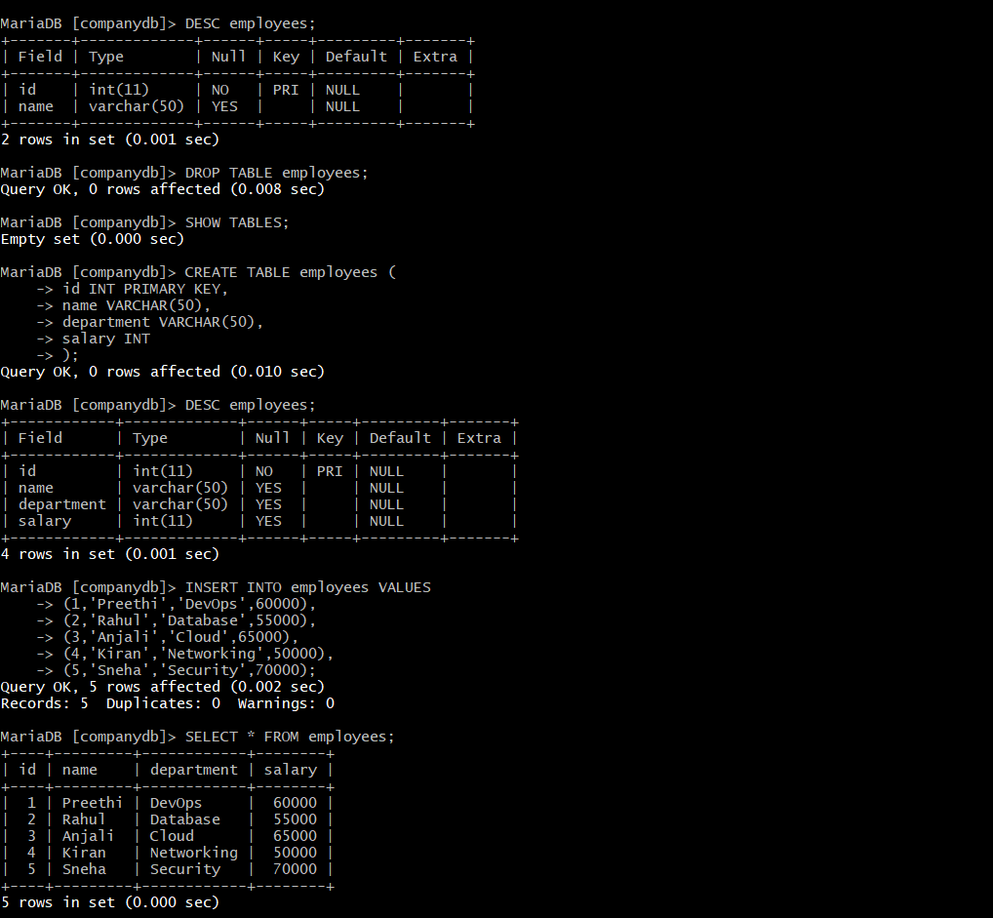
Yes, Task-3 is successfully completed. ✅
Your screenshots prove all required verification steps.

Task-3: Take Backup of Dummy Data on EC2
Objective
Create a backup of the MariaDB database running on the EC2 instance and verify that both table structure and data are included in the backup file.

Step 1: Connect to EC2 Instance
Connected to the EC2 instance using SSH.
ssh -i "ohiokey.pem" ec2-user@<public-ip>

Step 2: Exit MariaDB Console
Exited the MariaDB prompt.
exit;
Returned to Linux shell:
[ec2-user@ip-172-31-39-5 ~]$

Step 3: Create Database Backup
Used the mysqldump utility to export the database.
mysqldump -u root -p companydb > companydb_backup.sql
After entering the root password, AWS generated a backup file.

Step 4: Verify Backup File Creation
Checked whether the backup file was created successfully.
ls -lh
Output:
companydb_backup.sql
File size:
2.2 KB
This confirms that the backup file exists on the EC2 server.

Step 5: Verify Backup Content
Checked the first few lines of the backup.
head companydb_backup.sql
Output showed:
Database: companydb
Server version: 10.5.29-MariaDB
This confirms that the backup belongs to the correct database.

Step 6: Verify Data Backup
Searched for INSERT statements inside the backup file.
grep "INSERT INTO" companydb_backup.sql
Output:
INSERT INTO employees VALUES
(1,'Preethi','DevOps',60000),
(2,'Rahul','Database',55000),
(3,'Anjali','Cloud',65000),
(4,'Kiran','Networking',50000),
(5,'Sneha','Security',70000);
This confirms that employee records are stored inside the backup.

Step 7: Verify Full Backup
Viewed the complete backup file.
cat companydb_backup.sql
Verification confirmed:
Table Structure
CREATE TABLE employees (
id int(11) NOT NULL,
name varchar(50),
department varchar(50),
salary int(11)
);
Data Records
INSERT INTO employees VALUES
(1,'Preethi','DevOps',60000),
(2,'Rahul','Database',55000),
(3,'Anjali','Cloud',65000),
(4,'Kiran','Networking',50000),
(5,'Sneha','Security',70000);

Verification
Verified the following:
Check | Status
MariaDB running on EC2 | ✅
companydb database exists | ✅
employees table exists | ✅
Dummy records inserted | ✅
Backup file created | ✅
Table structure backed up | ✅
Data backed up | ✅

Conclusion
Successfully created a MariaDB database backup on the EC2 instance using the mysqldump utility. The generated backup file (companydb_backup.sql) contains both the database schema and all employee records, ensuring that the database can be restored whenever required.
Task-3 Completed Successfully. ✅

Interview Question
Q: What is mysqldump?
Answer:
mysqldump is a command-line utility used to create logical backups of MySQL and MariaDB databases. It exports database objects such as tables, schemas, and records into a SQL file, which can later be used to restore the database."How do you take a backup of a MariaDB/MySQL database on EC2?" → Use mysqldump. 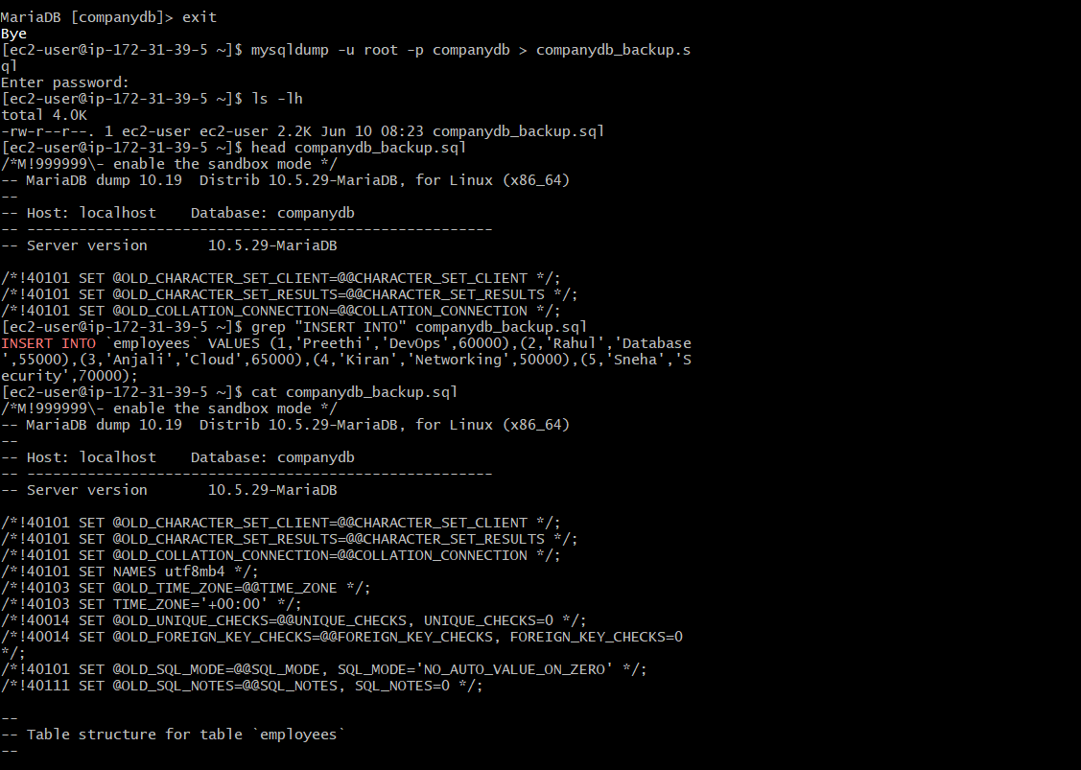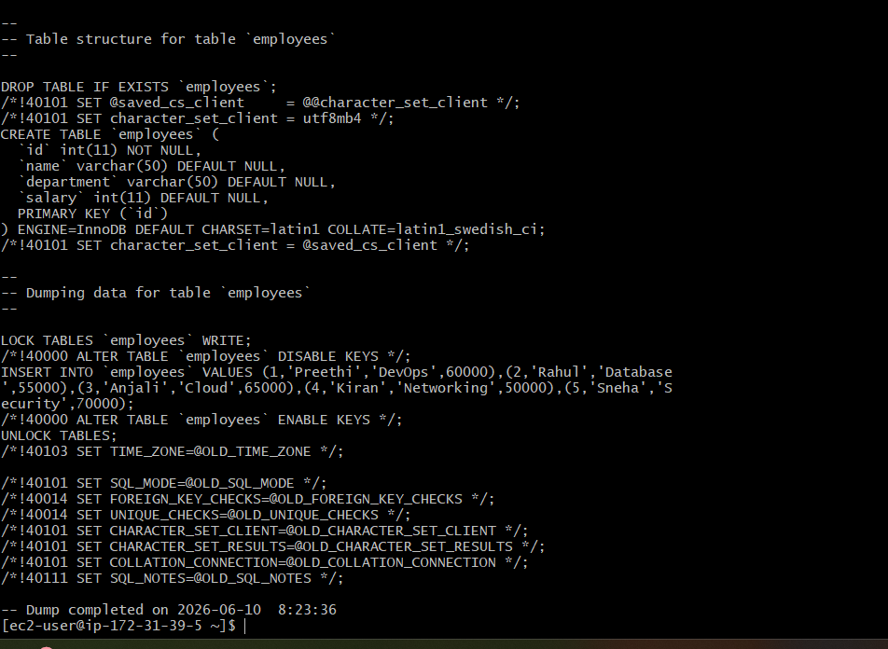
Task-4: Launch MariaDB RDS Instance
Objective
Create an Amazon RDS MariaDB database instance and verify connectivity from an EC2 instance.

Architecture
EC2 Instance
|
|
V
MariaDB RDS Instance
Instead of installing MariaDB inside EC2, AWS manages the database server for you.

Step 1: Open RDS Service
- Login to AWS Console
- Search RDS
- Open Amazon RDS
- Click Create Database

Step 2: Choose Database Creation Method
Select:
Standard Create
Click:
MariaDB

Step 3: Select Engine Version
Choose latest available version.
Example:
MariaDB 11.x
or
MariaDB 10.x

Step 4: Select Template
Choose:
Free Tier
(for learning purpose)

Step 5: Configure DB Instance
DB Instance Identifier
mariadb-rds
Master Username
admin
Master Password
Password@123
(Use your own password)

Step 6: DB Instance Class
Select:
db.t3.micro

Step 7: Storage Configuration
Choose:
20 GB
General Purpose SSD (gp3)

Step 8: Connectivity
VPC
Select your DevOps VPC.
Example:
DevOps-ASG VPC

Public Access
For testing:
Yes
For production:
No

VPC Security Group
Create new security group or select existing.
Allow:
3306
from EC2 security group.
Example:
Type: MySQL/Aurora
Port: 3306
Source: EC2 Security Group

Step 9: Additional Configuration
Initial Database Name
companydb

Backup Retention
7 Days
(Default is fine)

Monitoring
Leave default.

Maintenance
Leave default.

Step 10: Create Database
Click:
Create Database

Step 11: Wait for RDS Creation
Status changes:
Creating
↓
Available
This may take 5-10 minutes.

Step 12: Verify RDS Endpoint
After database becomes Available:
Click RDS instance.
Under:
Connectivity & Security
Copy:
Endpoint
Example:
mariadb-rds.xxxxxx.us-east-1.rds.amazonaws.com

Step 13: Connect from EC2
SSH into EC2:
ssh -i key.pem ec2-user@<public-ip>
Install MariaDB client if needed:
sudo dnf install mariadb105 -y

Step 14: Test Connection
Use RDS endpoint:
mysql -h mariadb-rds.xxxxxx.us-east-1.rds.amazonaws.com -u admin -p
Enter password.
If successful:
Welcome to MariaDB monitor

Step 15: Verify Database
Run:
SHOW DATABASES;
Expected:
companydb
information_schema
mysql
performance_schema

Verification
AWS Console Verification
RDS Status:
Available
Engine:
MariaDB
Instance Type:
db.t3.micro
Storage:
20 GB

Connectivity Verification
Run:
SHOW DATABASES;
Successfully displays databases.

Documentation Conclusion
Successfully launched an Amazon RDS MariaDB instance using the AWS RDS service. Configured database settings, networking, security groups, and verified connectivity from an EC2 instance using the RDS endpoint. The database is now managed by AWS and available for application connectivity.

Interview Question
Q: What is the difference between MariaDB on EC2 and MariaDB on RDS?
MariaDB on EC2 | MariaDB on RDS
You manage server | AWS manages server
Manual backups | Automated backups
Manual patching | Automatic patching
Manual scaling | Easy scaling
More administration effort | Fully managed service
Real-world scenario:
Most companies use RDS MariaDB instead of installing MariaDB on EC2 because AWS handles backups, maintenance, monitoring, patching, and high availability automatically.

Task 4: Launch MariaDB RDS Instance
Objective
Create a fully managed MariaDB database using Amazon RDS and configure it with basic settings for testing and learning purposes.

Step 1: Open RDS Service
- Login to AWS Management Console.
- Search for RDS in the search bar.
- Open Amazon RDS service.
- Navigate to:
RDS → Databases
- Click:
Create Database

Step 2: Select Database Engine
Under Engine Options:
Engine Type: MariaDB
Selected:
MariaDB 11.8.6
Purpose:
MariaDB is an open-source relational database engine compatible with MySQL.

Step 3: Choose Database Creation Method
Selected:
Full Configuration
Purpose:
Allows complete customization of the RDS instance settings.

Step 4: Configure Database Instance
Selected:
DB Instance Identifier:
mariadb-rds
Purpose:
Unique name for the RDS instance.

Step 5: Configure Credentials
Entered:
Master Username:
admin
Selected:
Self Managed Credentials
Created:
Master Password:
********
Purpose:
Used to connect and administer the MariaDB database.

Step 6: Configure Instance Size
Selected:
Instance Class:
db.t4g.micro
Purpose:
Free-tier eligible instance suitable for learning and testing.
Configuration:
2 vCPU
1 GB RAM

Step 7: Configure Storage
Selected:
Storage Type:
General Purpose SSD (gp2)
Allocated Storage:
20 GB
Purpose:
Stores database files, logs, and backups.

Step 8: Configure Availability
Selected:
Do Not Create Standby Instance
Multi-AZ:
Disabled
Purpose:
Reduces cost for non-production environments.

Step 9: Configure Connectivity
Selected:
IPv4
VPC:
Default VPC
Purpose:
Allows database communication within AWS network.

Step 10: Configure Public Access
Selected:
Public Access = Yes
Purpose:
Allows database access from external systems and local machines for testing purposes.
Note:
Production environments typically use:
Public Access = No
for enhanced security.

Step 11: Configure Security Group
Selected:
Choose Existing Security Group
Security Group:
default
Purpose:
Controls inbound and outbound traffic to the database instance.

Step 12: Configure Availability Zone
Selected:
No Preference
Purpose:
Allows AWS to automatically select an Availability Zone.

Step 13: Configure RDS Proxy
Selected:
Disabled
Purpose:
RDS Proxy is not required for this lab environment.

Step 14: Configure Database Options
Entered:
Initial Database Name:
companydb
Purpose:
Creates the database automatically during provisioning.

Step 15: Configure Encryption
Selected:
Enable Encryption
KMS Key:
aws/rds
Purpose:
Encrypts database storage for enhanced security.

Step 16: Configure Backup
Selected:
Enable Automated Backup
Backup Retention:
1 Day
Purpose:
Allows recovery of the database if data is accidentally lost.

Step 17: Configure Maintenance
Selected:
Enable Auto Minor Version Upgrade
Purpose:
Automatically applies minor MariaDB patches and updates.

Step 18: Configure Monitoring
Selected:
Database Insights Standard
Disabled:
Enhanced Monitoring
Purpose:
Provides basic performance monitoring without additional charges.

Step 19: Configure Deletion Protection
Selected:
Deletion Protection = Disabled
Purpose:
Allows easy deletion of the RDS instance after completing the lab.

Step 20: Create Database
Clicked:
Create Database
AWS started provisioning the MariaDB RDS instance.
Status:
Creating

Current Status
Database Identifier:
mariadb-rds
Engine:
MariaDB
Instance Type:
db.t4g.micro
Current Status:
Creating

Verification Steps (After Creation)
Once the status changes to:
Available
Verify the following:
Database Status
Available
Engine
MariaDB
Endpoint
Example:
mariadb-rds.xxxxx.us-east-2.rds.amazonaws.com
Port
3306
Database Name
companydb
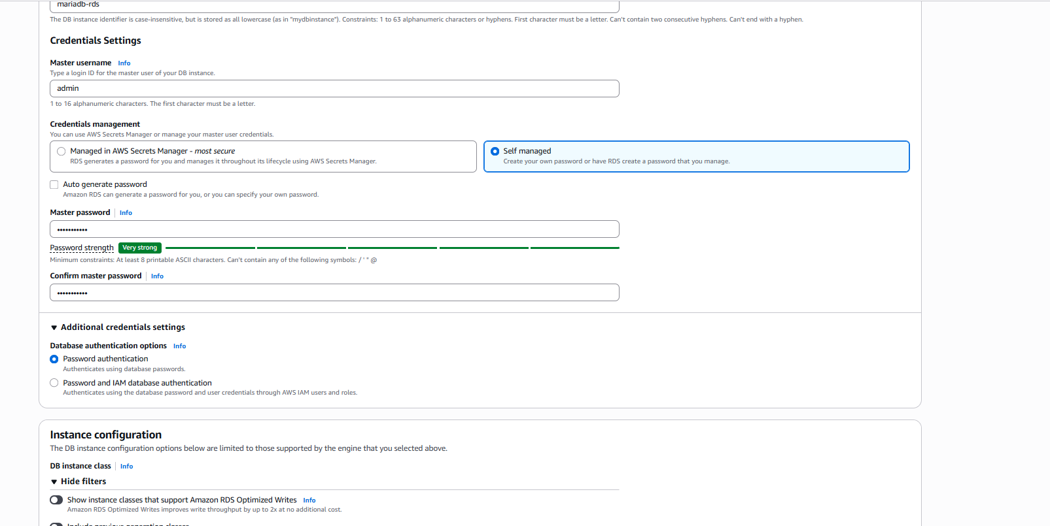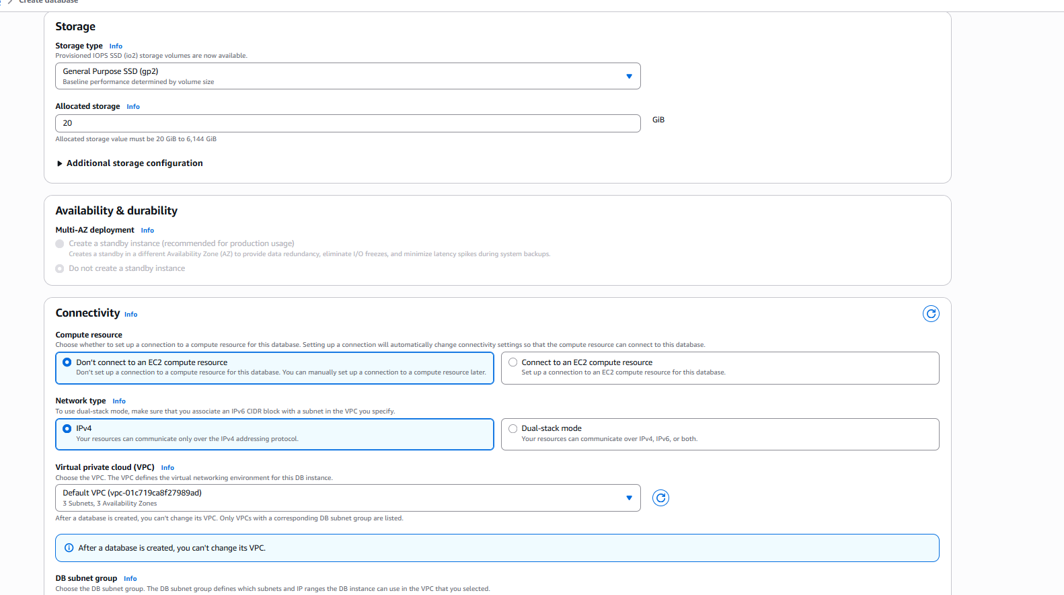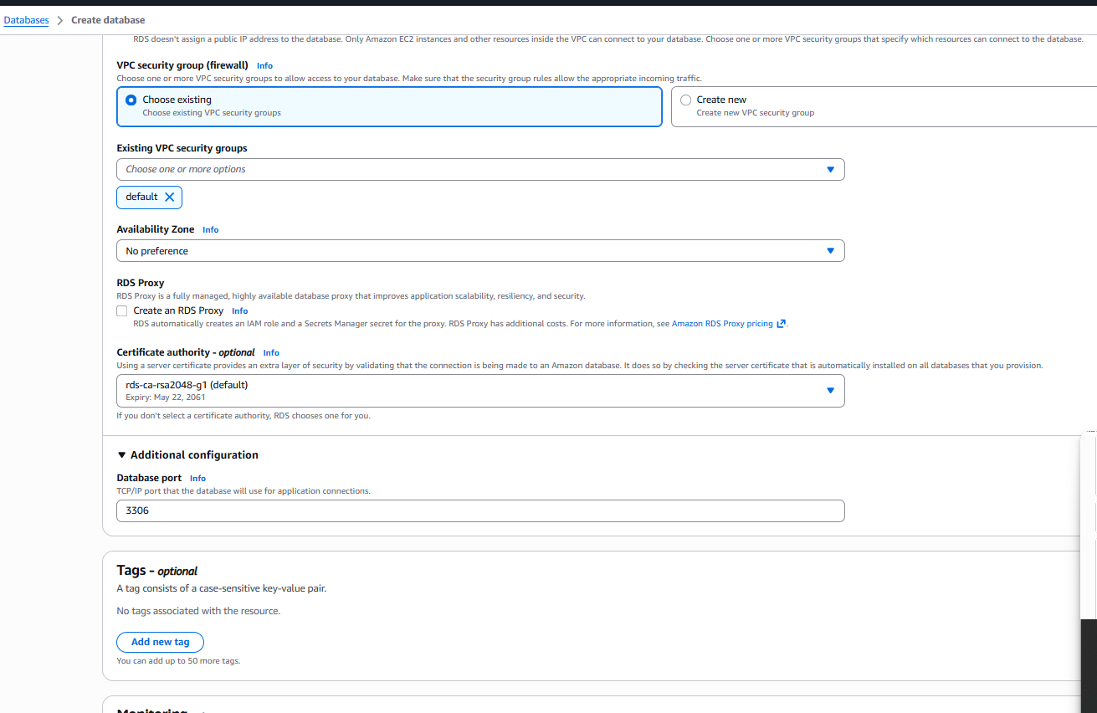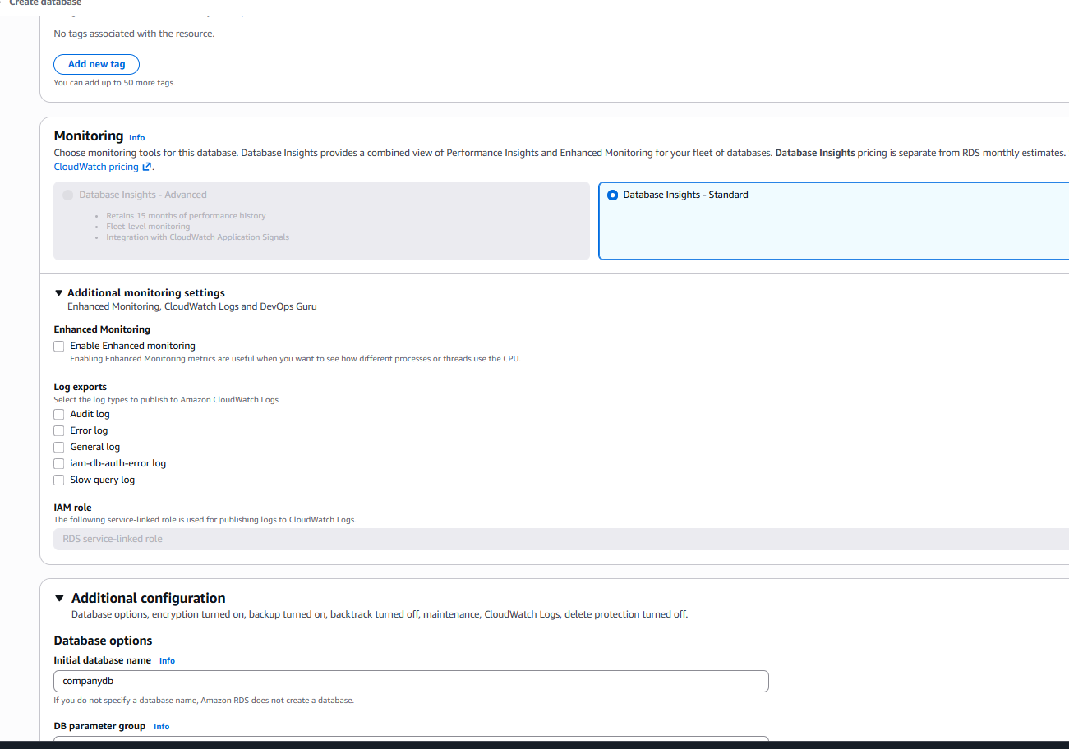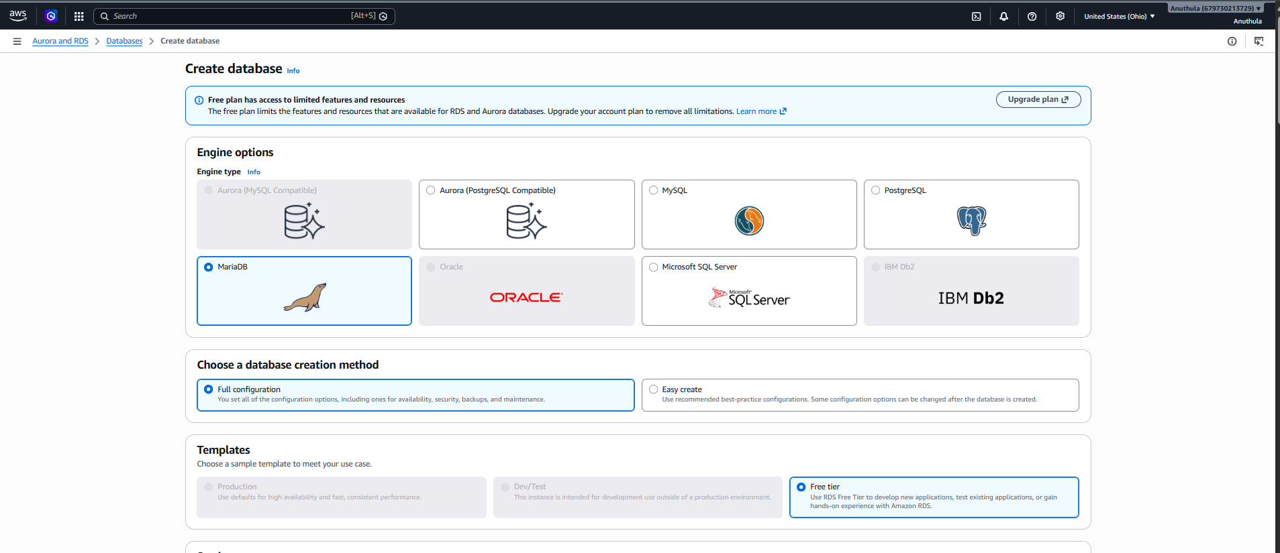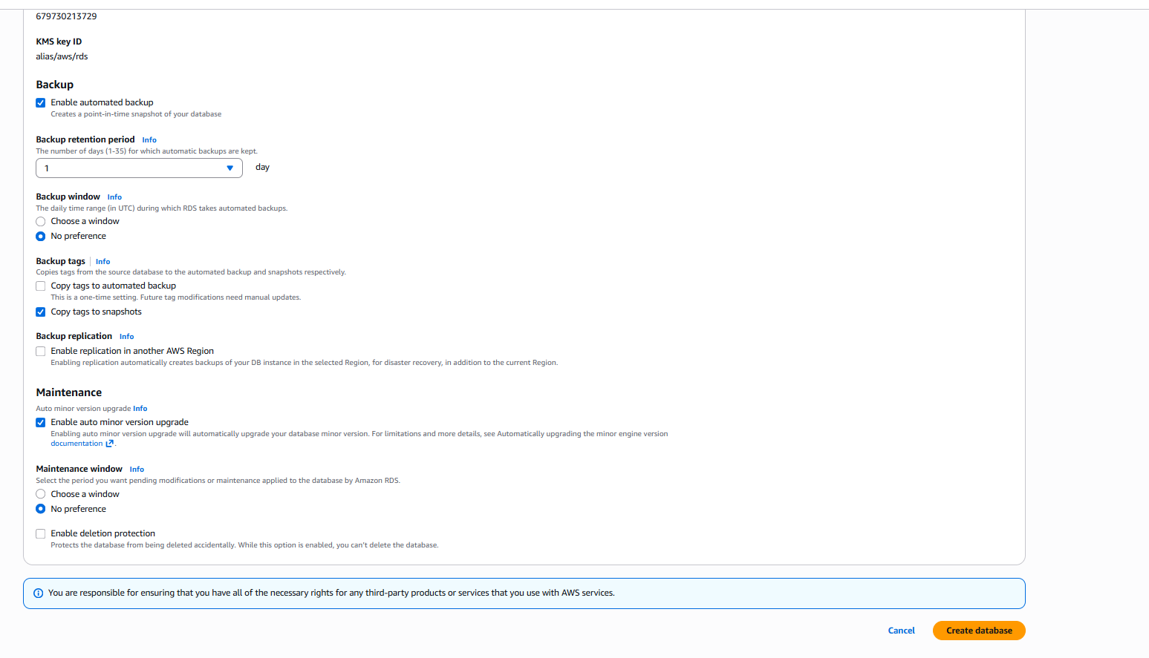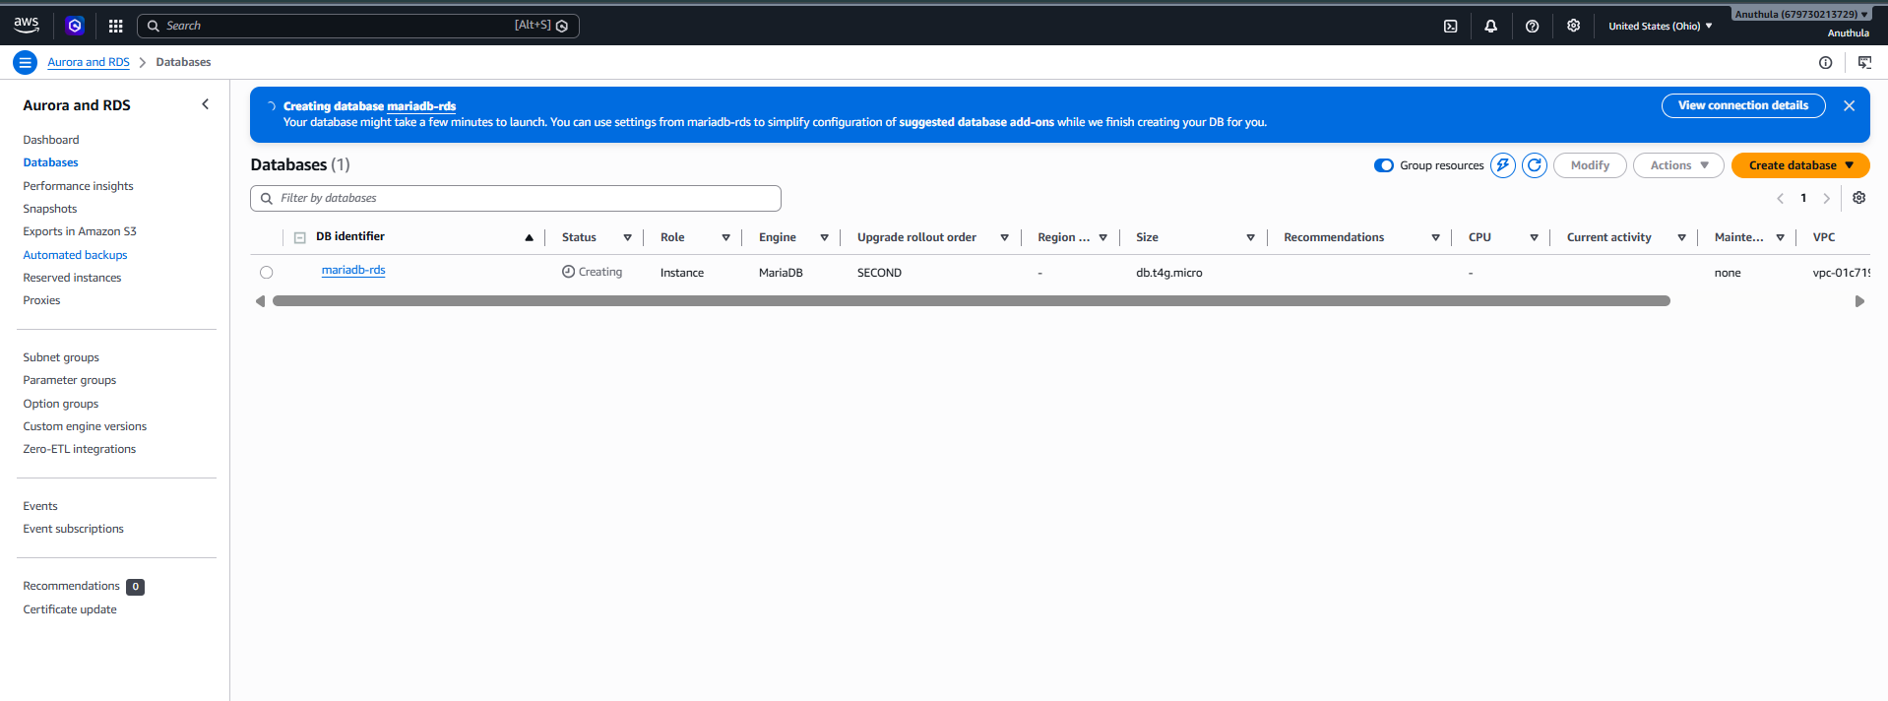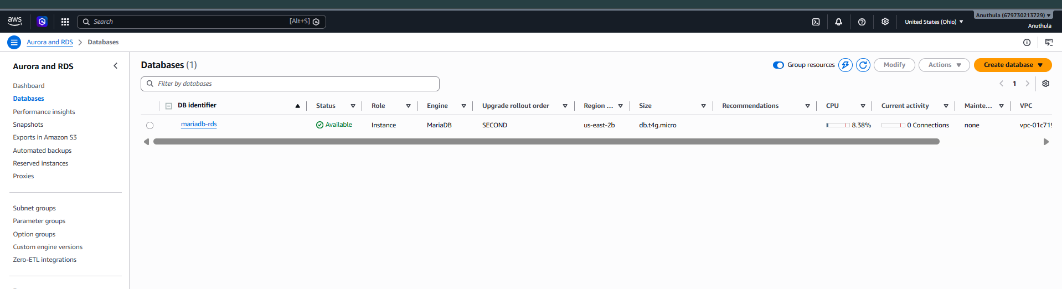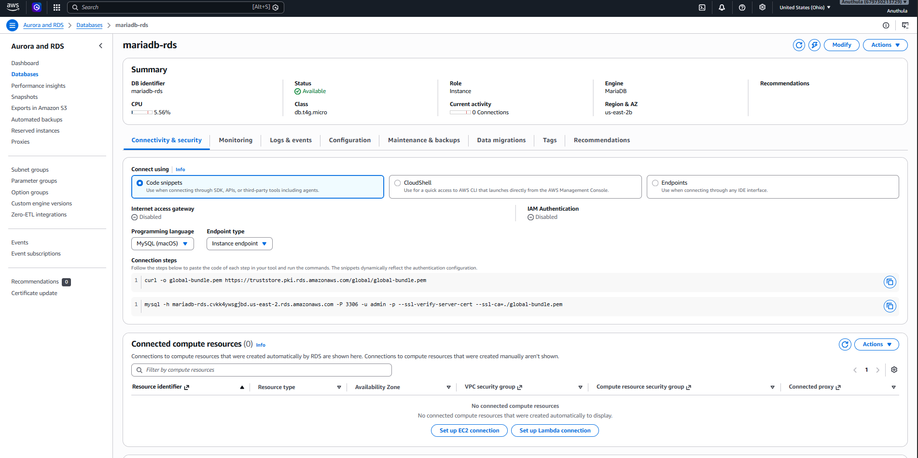Step 2: Select Database Engine
Under Engine Options:
Engine Type : MariaDB
Version : MariaDB 11.8.6
MariaDB was selected as the relational database engine.

Step 3: Choose Database Creation Method
Selected:
Standard Create
This allows custom configuration of the database instance.

Step 4: Configure Database Settings
Configured:
DB Identifier : mariadb-rds
Master Username : admin
Authentication : Password Authentication
Created and confirmed the master password.

Step 5: Configure Instance
Selected:
Instance Class : db.t4g.micro
Reason:
Suitable for testing and free-tier eligible workloads.

Step 6: Configure Storage
Selected:
Storage Type : General Purpose SSD (gp2)
Allocated Storage : 20 GiB

Step 7: Configure Availability
Selected:
Do not create standby instance
Reason:
Single-AZ deployment is sufficient for lab and testing purposes.

Step 8: Configure Connectivity
Selected:
Do not connect to EC2 automatically
Network Type : IPv4
VPC : Default VPC
Public Access:
No
Security Group:
Default Security Group
Availability Zone:
No Preference

Step 9: Configure Monitoring
Selected:
Database Insights : Standard
Enhanced Monitoring : Disabled

Step 10: Configure Backup
Enabled:
Automated Backups
Backup Retention : 1 Day

Step 11: Create Database
- Review all settings.
- Click Create Database.
- Wait for the status to change from:
Creating
to
Available

Result
Successfully created an Amazon RDS MariaDB instance.
DB Identifier : mariadb-rds
Engine : MariaDB
Instance Type : db.t4g.micro
Status : Available
Port : 3306

Interview Question
Why use RDS instead of installing MariaDB on EC2?
Answer:
RDS is a managed database service where AWS handles:
- Backups
- Patching
- Monitoring
- High Availability
- Storage Management
With EC2, all these activities must be managed manually by the administrator.
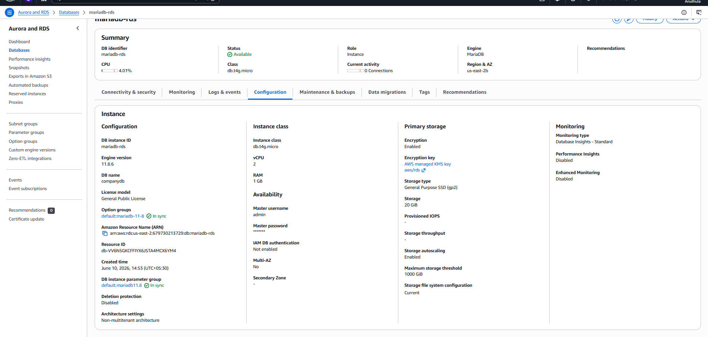

🎉 Excellent! Task 5 is completed successfully.
Your verification proves the migration worked:
Source (EC2 MariaDB)
companydb
└── employees
with data:
Preethi DevOps 60000
Rahul Database 55000
Anjali Cloud 65000
Kiran Networking 50000
Sneha Security 70000
Destination (RDS MariaDB)
USE companydb;
SHOW TABLES;
Output:
employees
and
SELECT * FROM employees;
returned all 5 records.

Task 5 Documentation
Task Name
Migrate Database from EC2 to Amazon RDS
Objective
Migrate an existing MariaDB database hosted on an EC2 instance to Amazon RDS MariaDB and verify successful data migration.

Architecture
MariaDB on EC2
|
| mysqldump
v
companydb.sql
|
| mysql import
v
Amazon RDS MariaDB

Step 1: Verify Database on EC2
Connected to the EC2 instance:
ssh -i "ohiokey.pem" ec2-user@<EC2-Public-IP>
Verified MariaDB installation:
mysql --version
Logged into MariaDB:
sudo mysql
Checked available databases:
SHOW DATABASES;
Selected the database:
USE companydb;
Checked tables:
SHOW TABLES;
Verified employee records:
SELECT * FROM employees;

Step 2: Create Database Backup
Exited MariaDB:
EXIT;
Created a database dump:
sudo mysqldump companydb > companydb.sql
Verified backup file:
ls -lh
Output:
companydb.sql

Step 3: Create Amazon RDS MariaDB Instance
Created a new RDS database with the following configuration:
Parameter | Value
Engine | MariaDB
Version | 11.8.6
Instance Class | db.t4g.micro
Storage | 20 GiB
VPC | Default VPC
Public Access | No
Username | admin
SSL Encryption | Enabled
Waited until the RDS status became:
Available

Step 4: Configure Security Group
Identified EC2 Security Group:
sg-0b5649efd9d652ebc
Added inbound rule to RDS Security Group:
Type | Port | Source
MySQL/Aurora | 3306 | sg-0b5649efd9d652ebc
This allowed the EC2 instance to connect to RDS.

Step 5: Download SSL Certificate
Downloaded Amazon RDS certificate bundle:
curl -O https://truststore.pki.rds.amazonaws.com/global/global-bundle.pem
Verified:
ls
Output:
global-bundle.pem

Step 6: Connect to Amazon RDS
Connected securely using SSL:
mysql -h mariadb-rds.cvkk4ywsgjbd.us-east-2.rds.amazonaws.com \
-u admin \
-p \
--ssl-ca=global-bundle.pem
Verified connection:
SHOW DATABASES;
Created target database:
CREATE DATABASE companydb;

Step 7: Import Database into RDS
Exited MariaDB:
EXIT;
Imported dump file into RDS:
mysql -h mariadb-rds.cvkk4ywsgjbd.us-east-2.rds.amazonaws.com \
-u admin \
-p \
--ssl-ca=global-bundle.pem \
companydb < companydb.sql

Step 8: Verify Migration
Connected again to RDS:
mysql -h mariadb-rds.cvkk4ywsgjbd.us-east-2.rds.amazonaws.com \
-u admin \
-p \
--ssl-ca=global-bundle.pem
Selected database:
USE companydb;
Checked tables:
SHOW TABLES;
Output:
employees
Verified records:
SELECT * FROM employees;
Output:
Preethi DevOps 60000
Rahul Database 55000
Anjali Cloud 65000
Kiran Networking 50000
Sneha Security 70000

Result
Successfully migrated the companydb database from MariaDB running on EC2 to Amazon RDS MariaDB using mysqldump export and mysql import. Data integrity was verified by comparing the records before and after migration. ✅
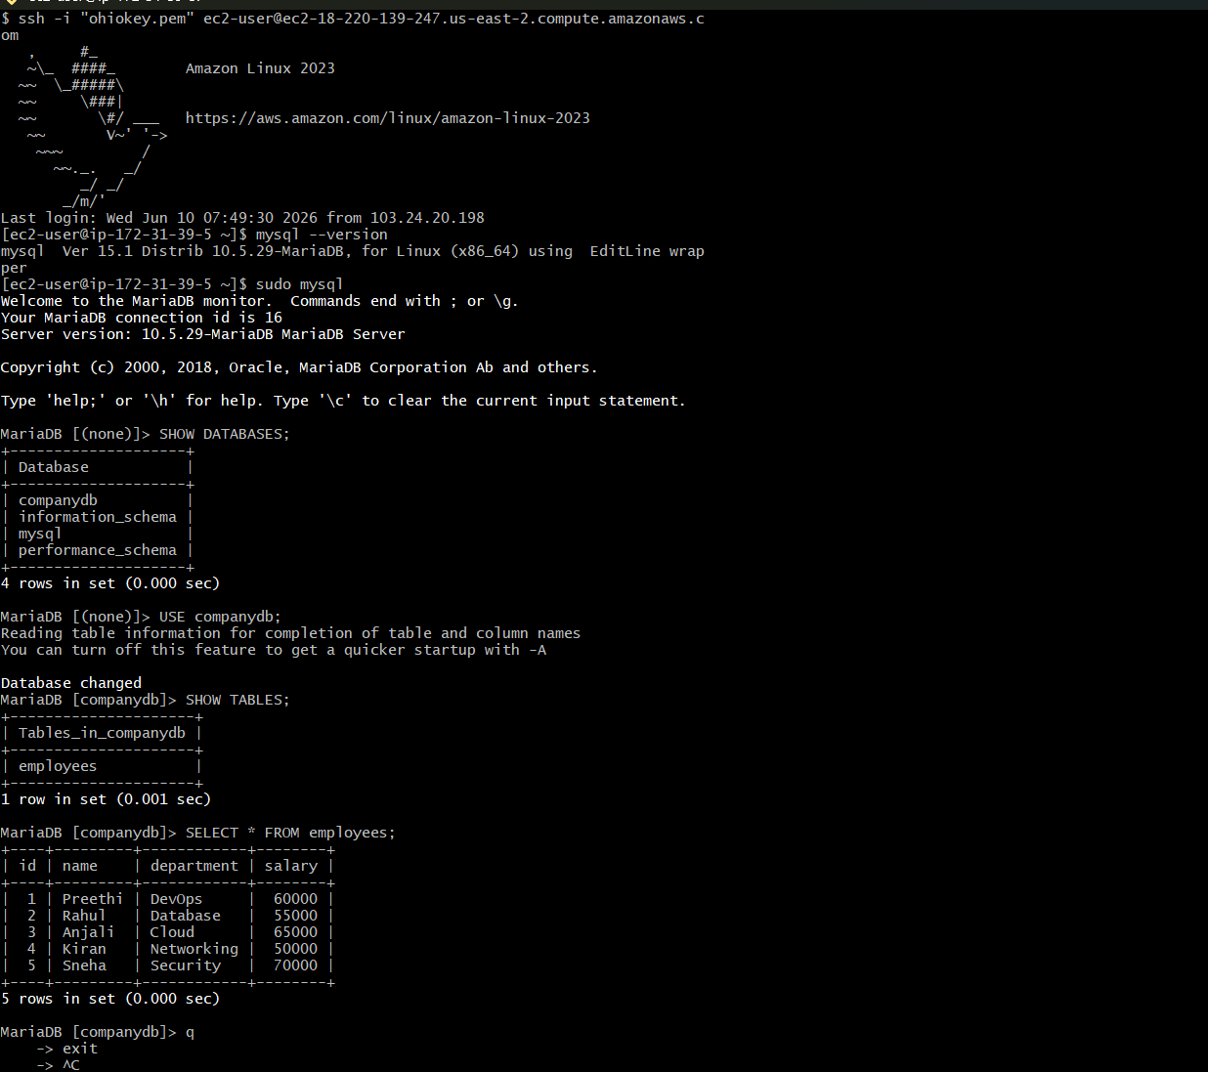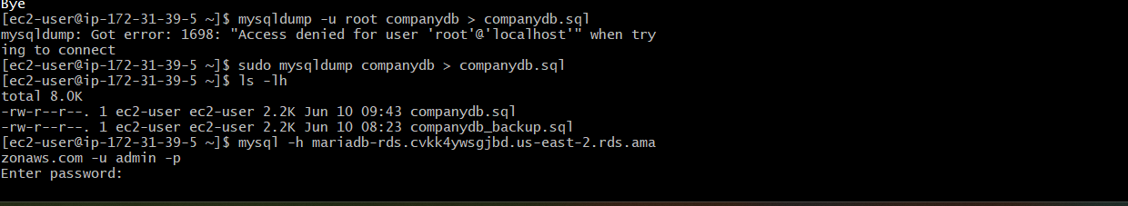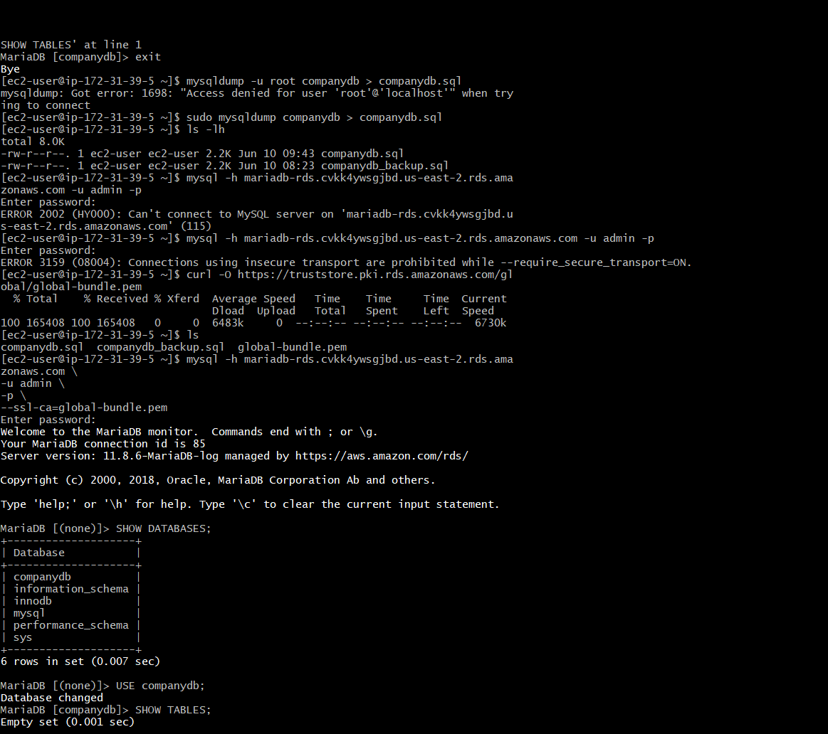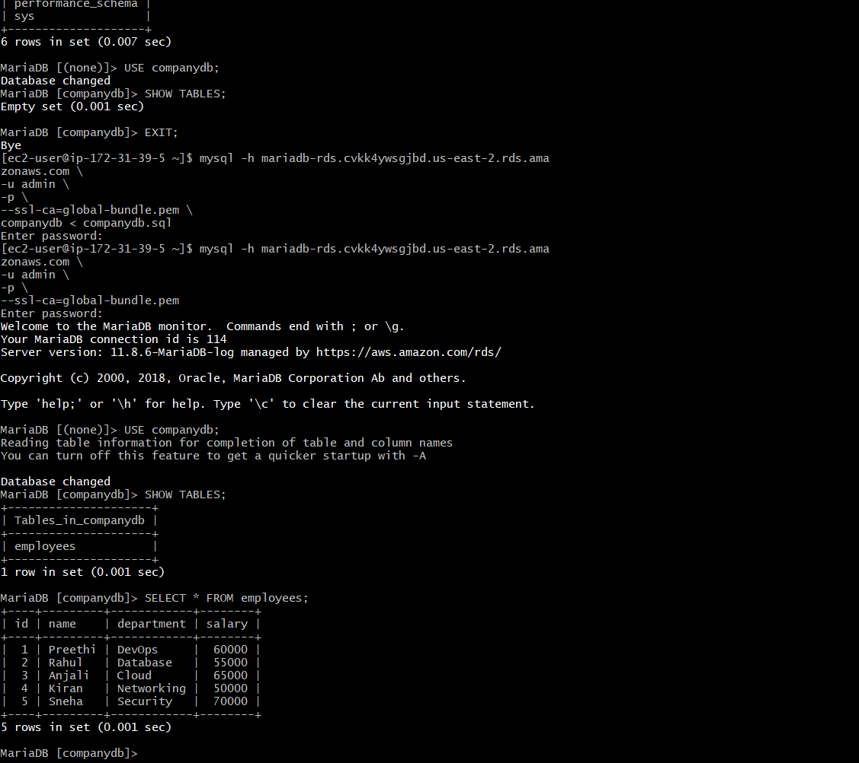

Task 6: Install MySQL Database on EC2
Objective
Install a MySQL-compatible database server (MariaDB) on an Amazon EC2 instance, create a sample database and table, and verify successful database operations.

Step 1: Launch EC2 Instance
- Navigate to EC2 Console.
- Click Launch Instance.
- Select Amazon Linux 2023 AMI.
- Choose t3.micro instance type.
- Configure Security Group:
  - SSH (22) from My IP.
- Launch the instance using an existing key pair.
Verification
Verify that the EC2 instance is in the Running state.

Step 2: Connect to EC2 Instance
Connect to the EC2 instance using SSH.
ssh -i "ohiokey.pem" ec2-user@<Public-IP>
Verification
Successful login to the EC2 terminal.

Step 3: Update the Server
Update all installed packages.
sudo dnf update -y
Verification
System packages are updated successfully without errors.

Step 4: Install MariaDB Server
Install MariaDB server package.
sudo dnf install mariadb105-server -y
Verification
Check installed package:
rpm -qa | grep -i maria
Output displays MariaDB server package details.

Step 5: Start MariaDB Service
Start the MariaDB database service.
sudo systemctl start mariadb
Verification
Check service status:
sudo systemctl status mariadb
Expected Output:
Active: active (running)

Step 6: Enable MariaDB Service
Configure MariaDB to start automatically during system boot.
sudo systemctl enable mariadb
Verification
sudo systemctl is-enabled mariadb
Expected Output:
enabled

Step 7: Verify Database Port
Verify that MariaDB is listening on port 3306.
sudo netstat -tulpn | grep 3306
Expected Output:
tcp6 0 0 :::3306 :::* LISTEN
This confirms that the MariaDB server is actively listening for database connections.

Step 8: Login to MariaDB
Access the MariaDB database.
sudo mysql
Verification
Expected Prompt:
MariaDB [(none)]>

Step 9: Verify Existing Databases
Display available databases.
SHOW DATABASES;
Expected Output:
information_schema
mysql
performance_schema

Step 10: Create Sample Database
Create a new database named testdb.
CREATE DATABASE testdb;
Verify:
SHOW DATABASES;
Expected Output:
testdb

Step 11: Use Database
Switch to the newly created database.
USE testdb;
Expected Output:
Database changed

Step 12: Create Table
Create a sample employee table.
CREATE TABLE employees (
id INT PRIMARY KEY,
name VARCHAR(50)
);
Verification
SHOW TABLES;
Expected Output:
employees

Step 13: Insert Sample Data
Insert sample records.
INSERT INTO employees VALUES
(1,'Preethi'),
(2,'Rahul');
Verification
Expected Output:
Query OK, 2 rows affected

Step 14: Verify Data
Retrieve records from the employees table.
SELECT * FROM employees;
Expected Output:
+----+---------+
| id | name |
+----+---------+
| 1 | Preethi |
| 2 | Rahul |
+----+---------+

Result
Successfully installed MariaDB (MySQL-compatible database) on an Amazon EC2 instance, started and enabled the database service, created a sample database and table, inserted records, and verified successful database operations. The MariaDB service was confirmed to be listening on port 3306 and functioning correctly. ✅
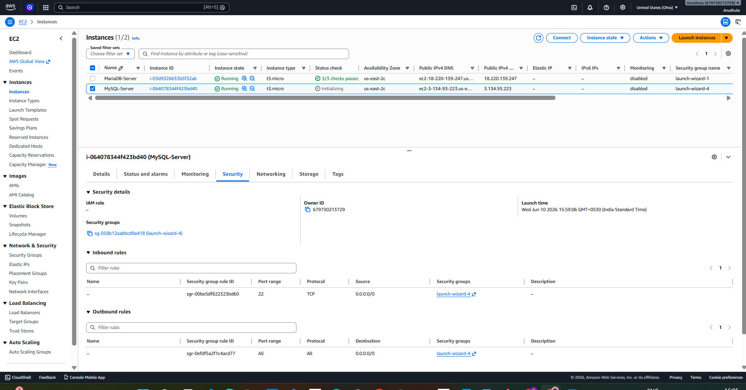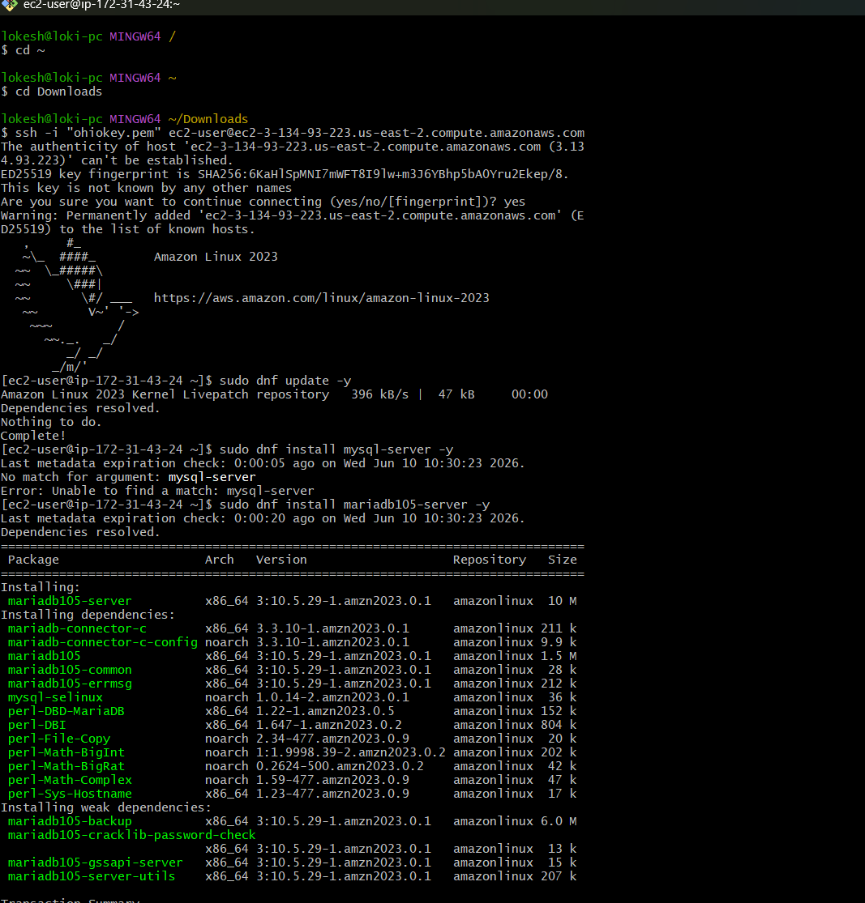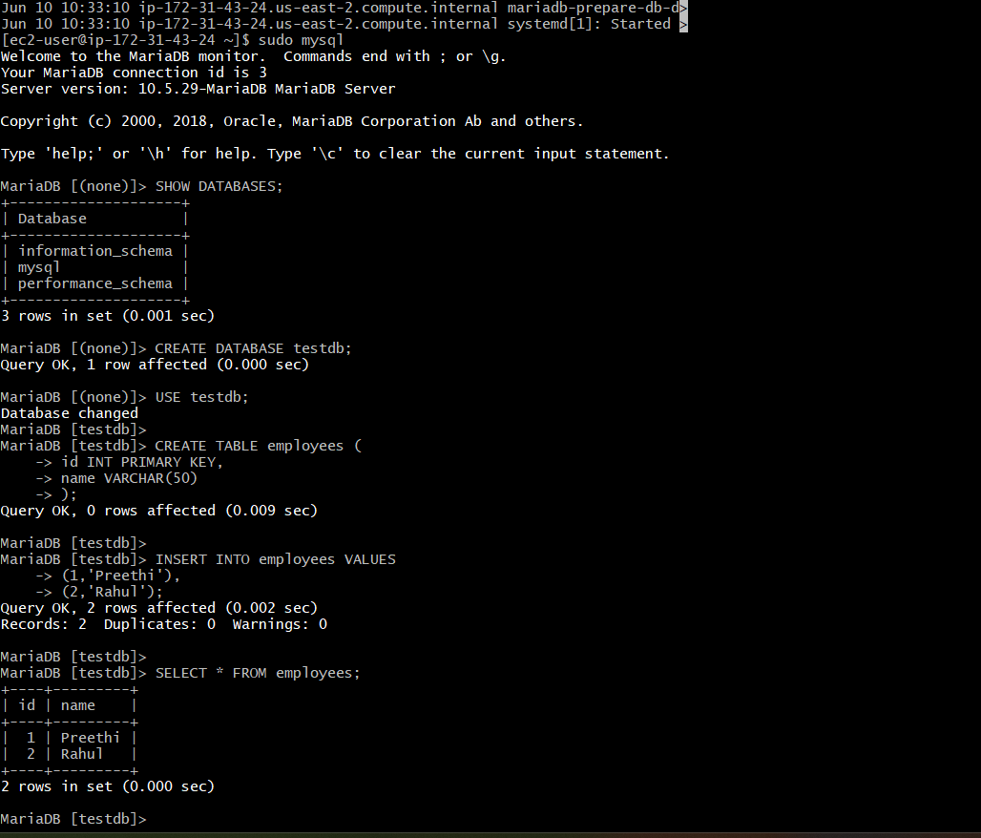
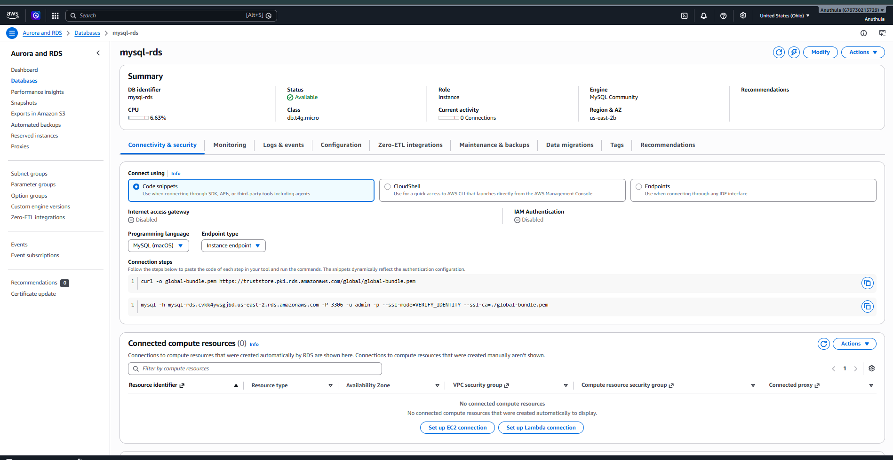
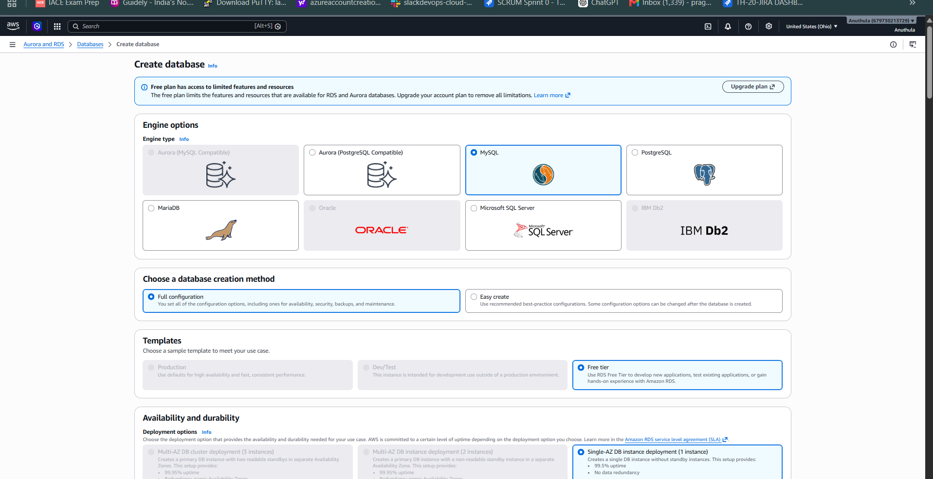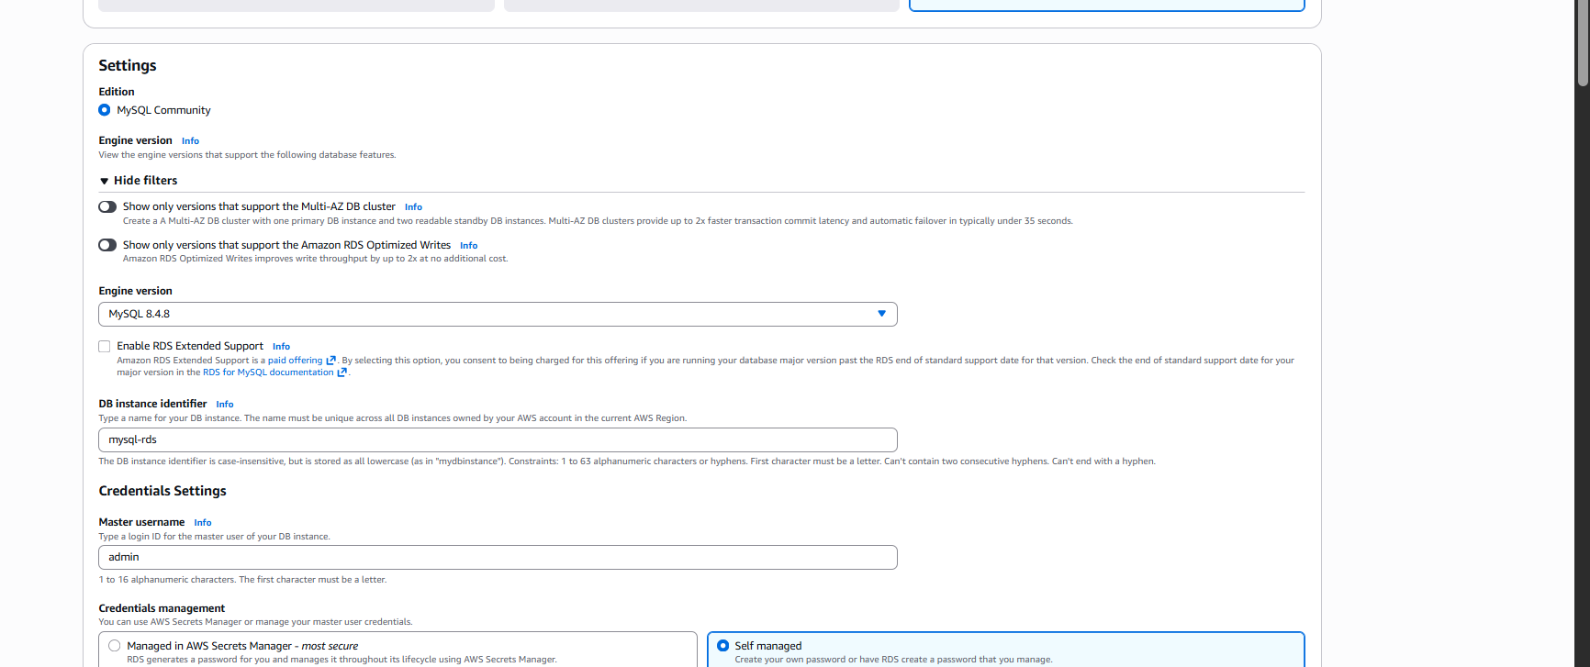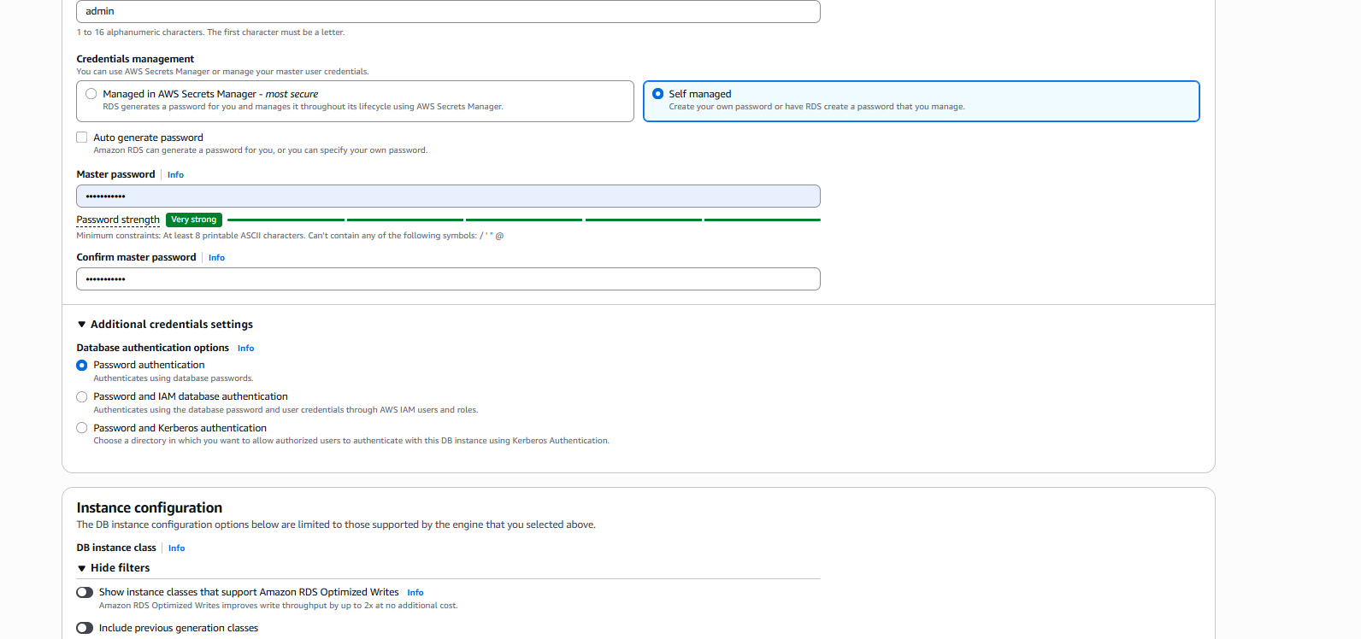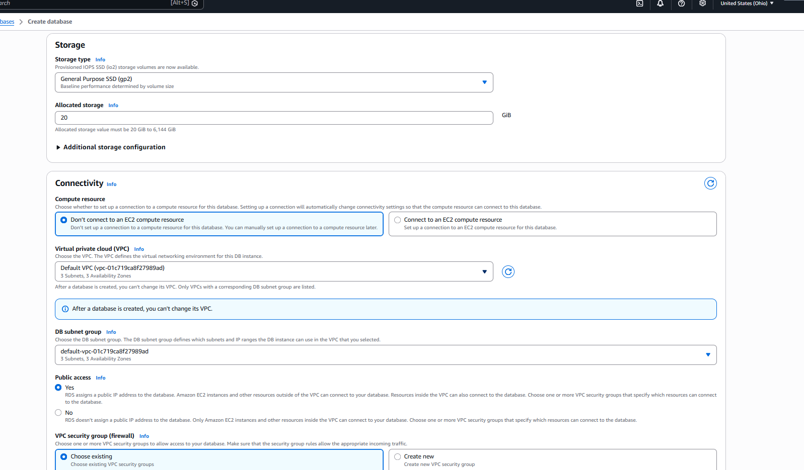
Task-8: Configure Multi-AZ for MySQL RDS
Objective
Configure Multi-AZ deployment for the MySQL RDS instance to provide high availability and automatic failover by maintaining a standby database instance in a separate Availability Zone.
Steps Performed
- Logged in to the AWS Management Console.
- Navigated to Amazon RDS.
- Selected the MySQL RDS instance (mysql-rds).
- Clicked Modify.
- Navigated to the Availability & Durability section.
- Reviewed the Multi-AZ Deployment settings.
- Verified that the option to create a standby instance was unavailable (greyed out).
Observation
The Multi-AZ deployment option was disabled and could not be selected.
Reason
The selected RDS configuration is using a Free Tier eligible instance class (db.t4g.micro). Multi-AZ deployment requires AWS to create an additional standby database instance in another Availability Zone, which is not supported under the current configuration and may incur additional charges.
Result
Attempted to enable Multi-AZ deployment for the MySQL RDS instance. The option was unavailable (greyed out) due to the selected free-tier instance configuration. Multi-AZ requires creation of a standby instance in a separate Availability Zone and may incur additional charges.
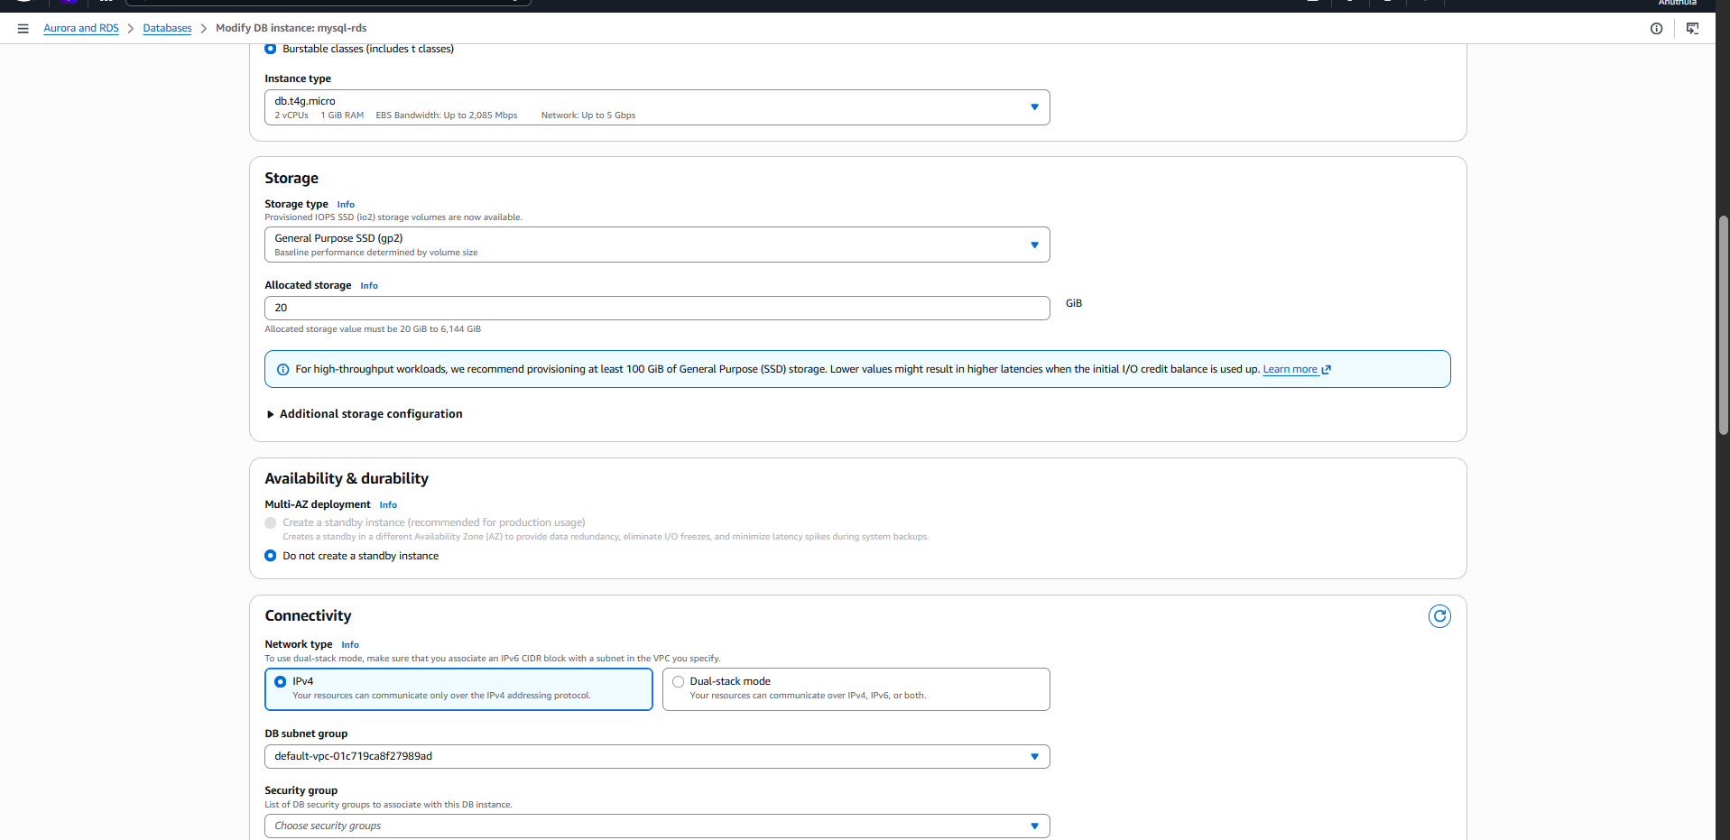
Task 9: Take Backup of DB and Restore the DB
Objective
To create a backup of a MySQL RDS database using an RDS Snapshot and restore the snapshot into a new RDS instance.

Step 1: Create a Manual Snapshot
- Logged in to the AWS Management Console.
- Navigated to RDS → Databases.
- Selected the MySQL RDS instance (mysql-rds).
- Clicked Actions → Take Snapshot.
- Entered the snapshot name:
mysql-rds-snapshot
- Clicked Take Snapshot.
- Waited until the snapshot status changed to Available.

Step 2: Restore the Snapshot
- Navigated to RDS → Snapshots.
- Selected the snapshot mysql-rds-snapshot.
- Clicked Restore Snapshot.
- Provided a new DB instance identifier:
mysql-rds-restored
- Selected the required configuration:
  - Engine: MySQL
  - Instance Class: db.t4g.micro
  - VPC: Default VPC
  - Security Group: Default
  - Public Access: Enabled
- Clicked Restore DB Instance.
- Waited until the restored database status became Available.

Step 3: Configure Connectivity
- Modified the RDS Security Group.
- Added an inbound rule:
Type | Protocol | Port | Source
MySQL/Aurora | TCP | 3306 | EC2 Security Group
- Saved the Security Group rules.
- Verified that the EC2 instance could communicate with the restored RDS instance.

Step 4: Connect to the Restored Database
Connected to the EC2 instance and downloaded the SSL certificate:
curl -O https://truststore.pki.rds.amazonaws.com/global/global-bundle.pem
Connected to the restored MySQL RDS instance:
mysql -h mysql-rds-restored.cvkk4ywsgjbd.us-east-2.rds.amazonaws.com \
-u admin \
-p \
--ssl-ca=global-bundle.pem

Step 5: Verify the Restored Database
Listed all databases:
SHOW DATABASES;
Output:
information_schema
mysql
performance_schema
sys
testdb
Selected the database:
USE testdb;
Created the employees table:
CREATE TABLE employees (
id INT PRIMARY KEY,
name VARCHAR(50)
);
Inserted sample records:
INSERT INTO employees VALUES
(1,'Preethi'),
(2,'Rahul');
Verified the table:
SHOW TABLES;
Output:
employees
Verified the data:
SELECT * FROM employees;
Output:
+----+---------+
| id | name |
+----+---------+
| 1 | Preethi |
| 2 | Rahul |
+----+---------+

Result
- Successfully created a manual snapshot of the MySQL RDS instance.
- Successfully restored the snapshot into a new RDS instance (mysql-rds-restored).
- Connected to the restored database from an EC2 instance.
- Verified database accessibility.
- Created and validated the employees table in the restored database.
- Backup and restore operation completed successfully.
Conclusion
Amazon RDS Snapshot functionality was used to create a backup of the MySQL database and restore it into a new RDS instance. Connectivity was verified from EC2, and the restored database was successfully accessed and validated.
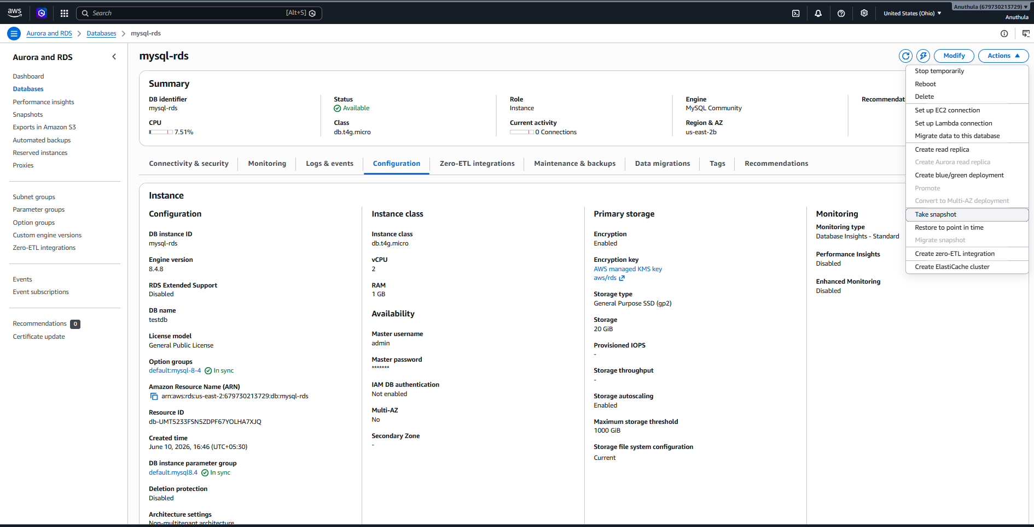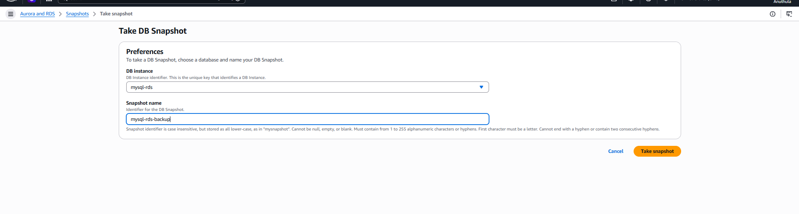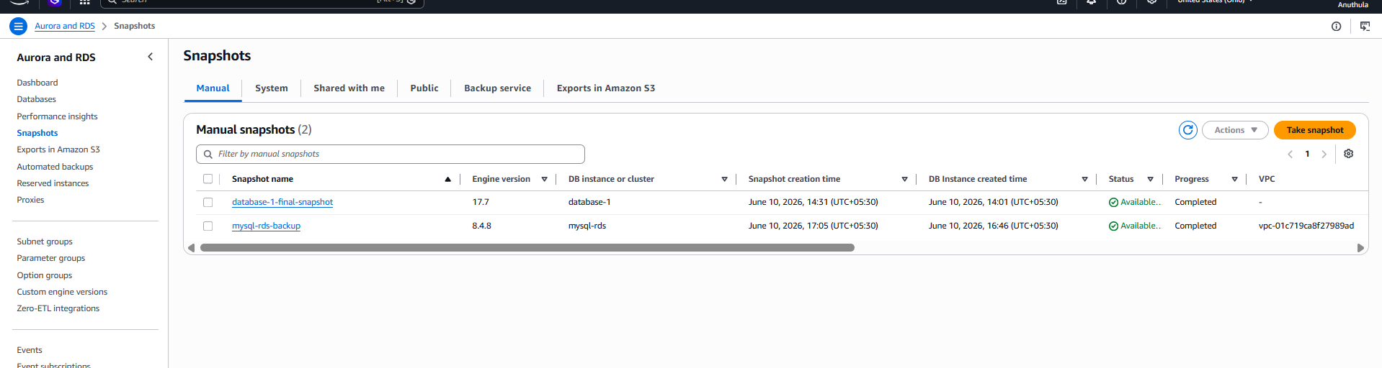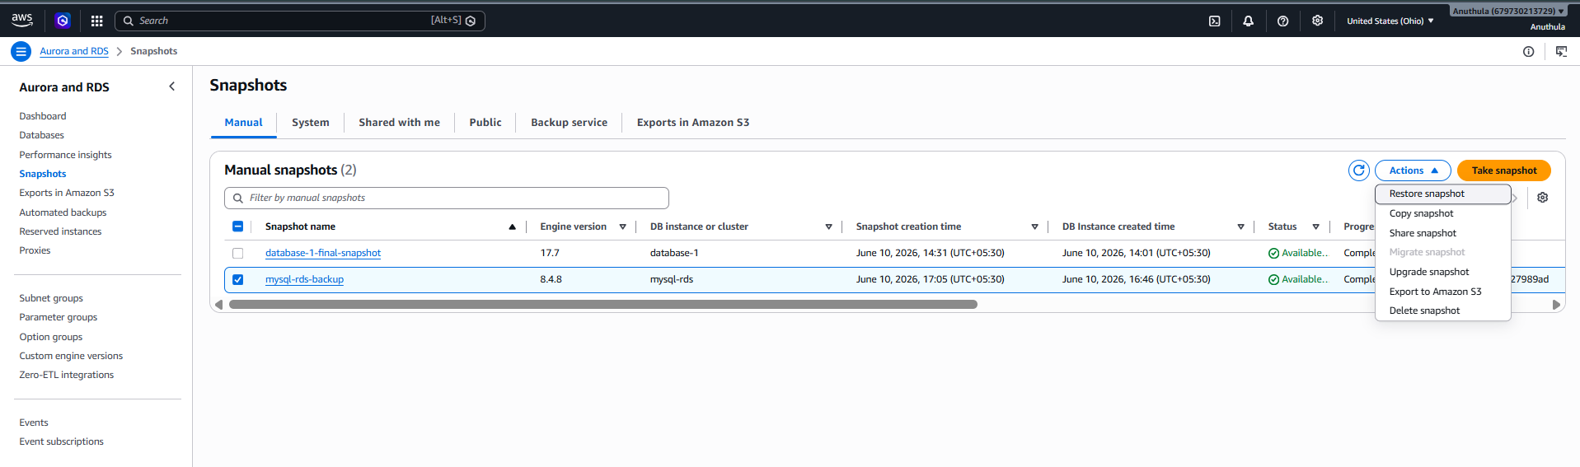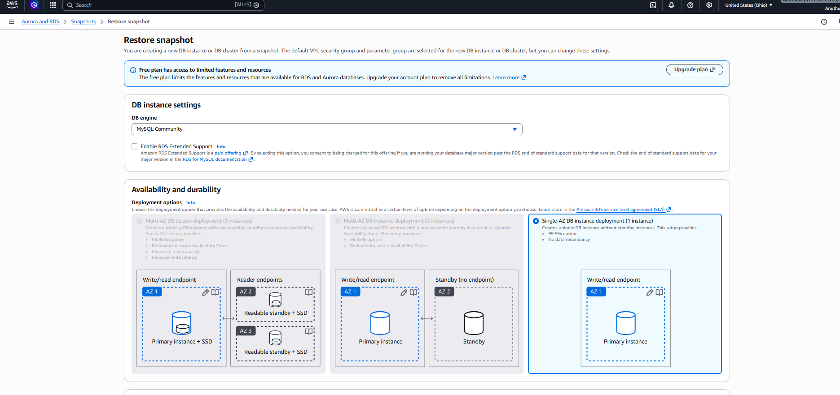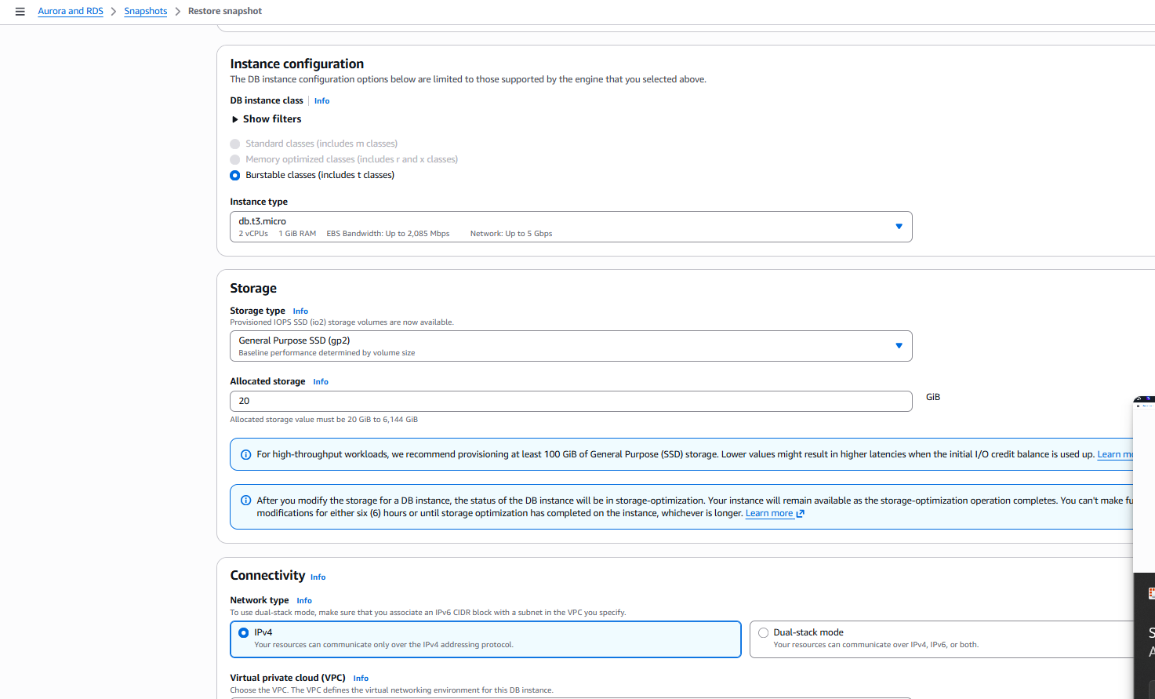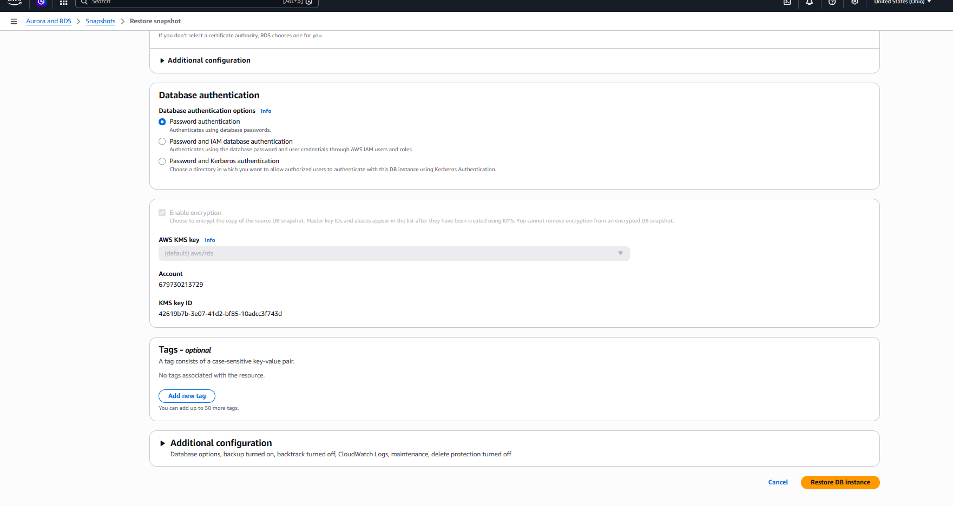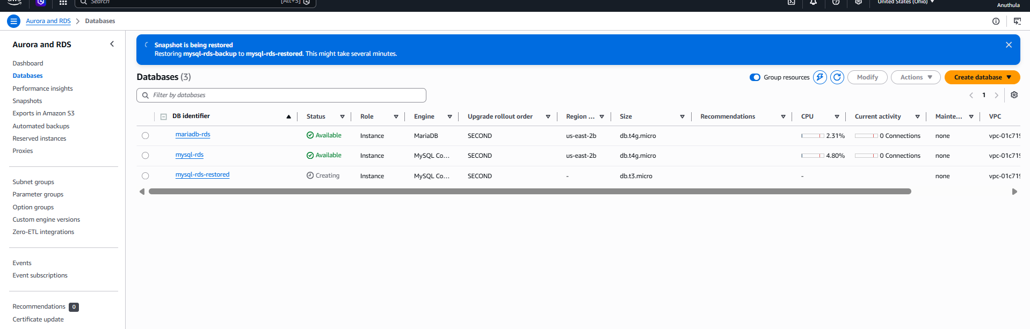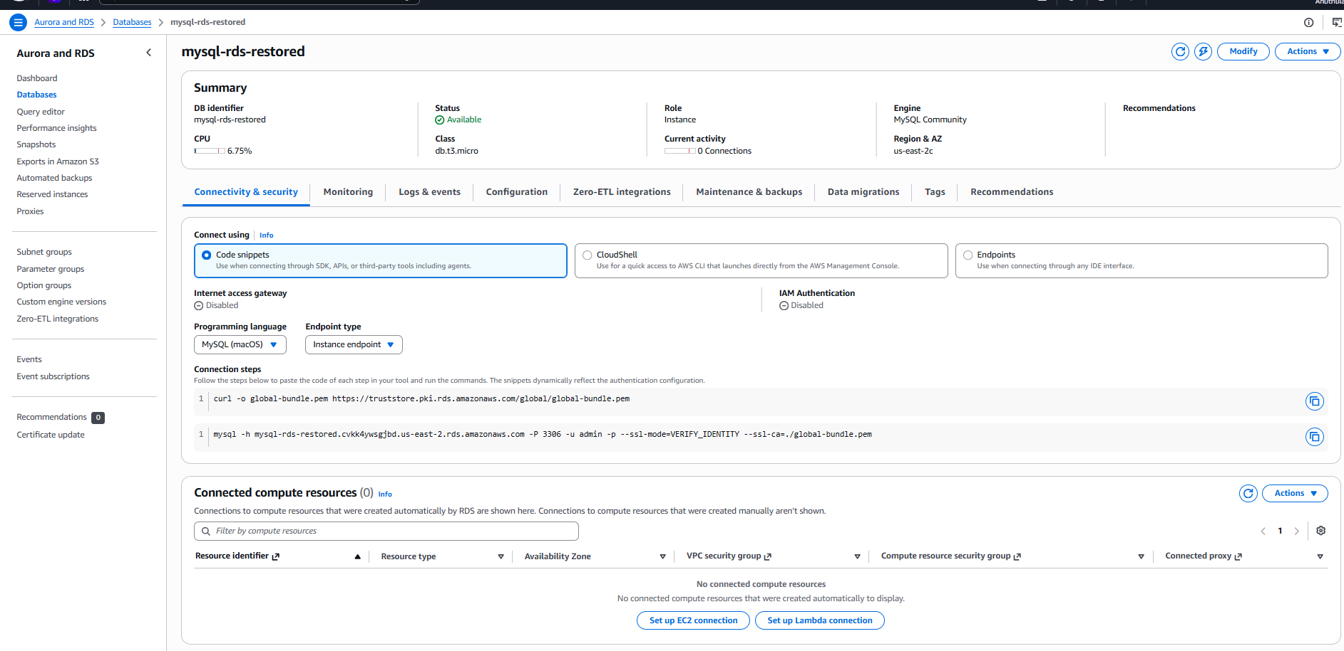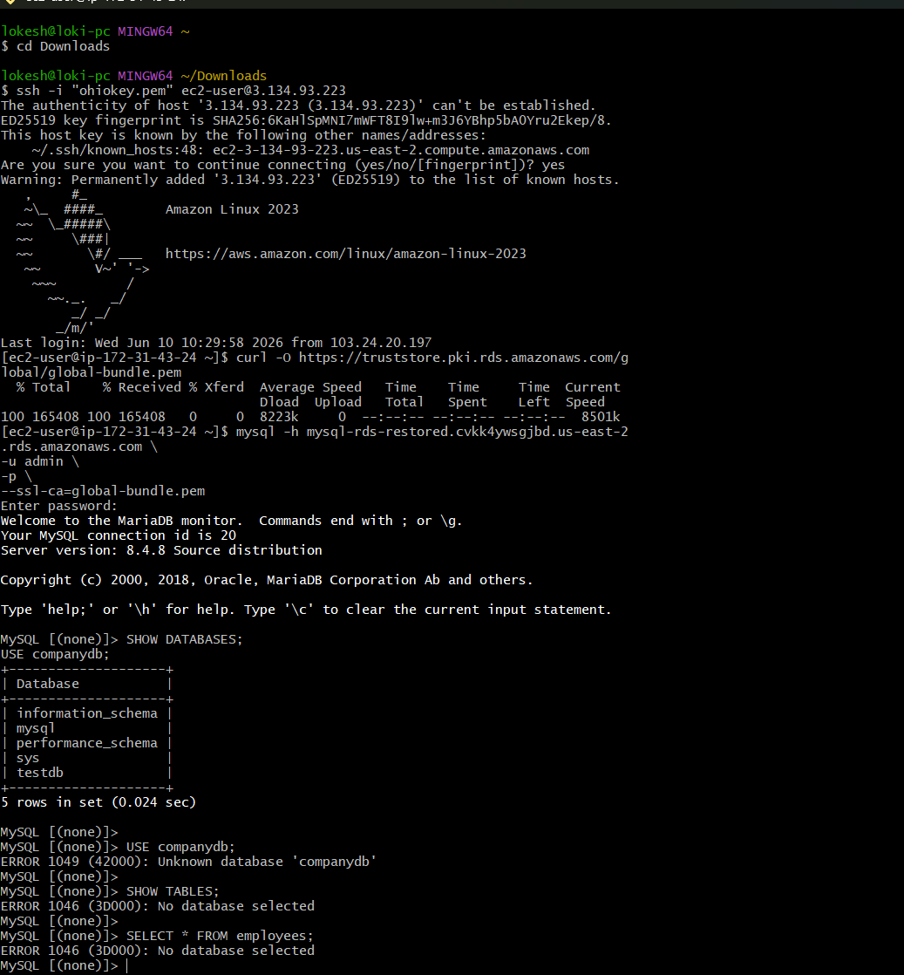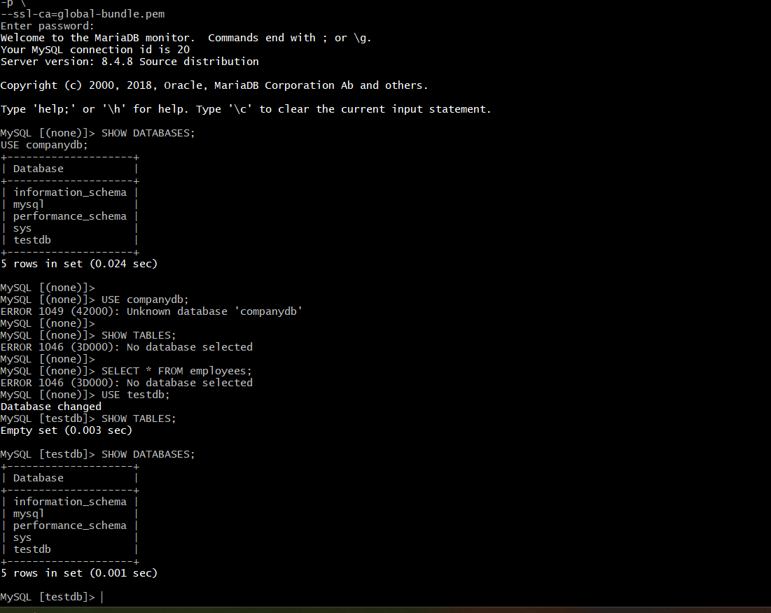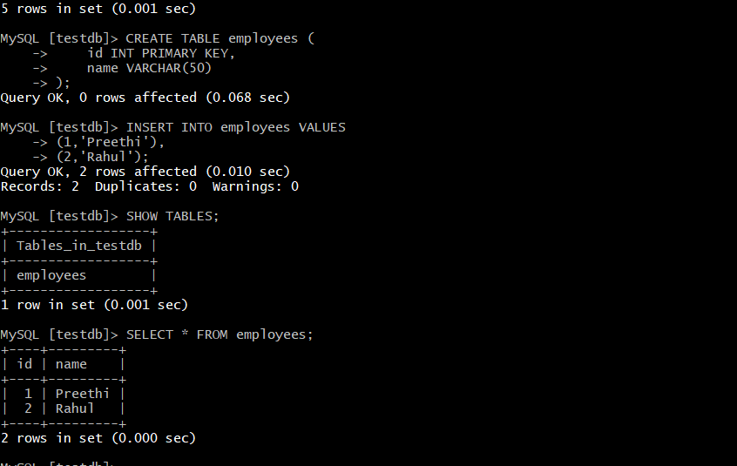

Task 10: Create Read Replica
Objective
The objective of this task is to create a Read Replica for an existing MySQL RDS instance. Read Replicas are used to improve database performance by offloading read operations from the primary database and providing a scalable architecture for reporting and analytics workloads.

Step 1: Open Amazon RDS Console
- Log in to the AWS Management Console.
- Navigate to Amazon RDS.
- Select Databases.
- Choose the existing MySQL RDS instance mysql-rds.

Step 2: Create Read Replica
- Select the source database mysql-rds.
- Click Actions.
- Select Create Read Replica.

Step 3: Configure Replica Settings
Configured the following settings:
Parameter | Value
Source Database | mysql-rds
Replica Identifier | mysql-rds-replica
Region | US East (Ohio)
Instance Class | db.t4g.micro
Storage Type | General Purpose SSD (gp2)
Allocated Storage | 20 GiB
Public Access | Enabled
VPC | Default VPC
Security Group | Default Security Group

Step 4: Launch Read Replica
- Reviewed the configuration settings.
- Clicked Create Read Replica.
- Waited for the replica status to change from:
Creating
to
Available

Step 5: Verify Replication
Connect to Primary Database
Connected to the primary MySQL RDS instance and verified the employees table.
USE testdb;

SELECT * FROM employees;
Output:
+----+---------+
| id | name |
+----+---------+
| 1 | Preethi |
| 2 | Rahul |
+----+---------+

Connect to Read Replica
Connected to the replica endpoint:
mysql -h mysql-rds-replica.cvkk4ywsgjbd.us-east-2.rds.amazonaws.com \
-u admin \
-p \
--ssl-ca=global-bundle.pem
Verified replication using:
SHOW DATABASES;
USE testdb;
SHOW TABLES;
SELECT * FROM employees;
Confirmed that the replica contained the same database objects and data as the primary database.

Result
Successfully created a MySQL Read Replica named mysql-rds-replica from the primary database instance mysql-rds. The replica synchronized data from the source database and was verified by connecting through the replica endpoint and querying the replicated tables and records. This setup can be used to distribute read traffic and improve database performance without impacting the primary database instance.
